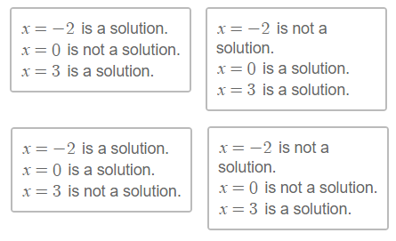 | 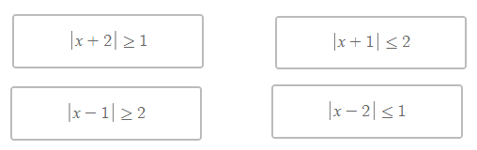
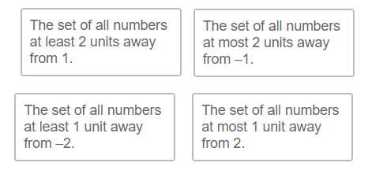 | 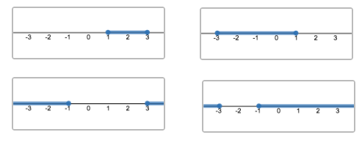

Absolute Value Inequality Card Sort Activity 1: This is a paper-based extension/adaptation of a part of a Desmos Class Activity
Source: https://teacher.desmos.com/dashboard/5ce95b36ede3ee69f744c68d
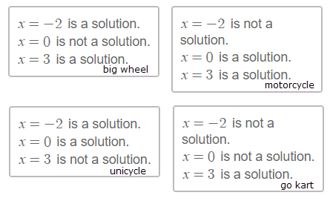 | 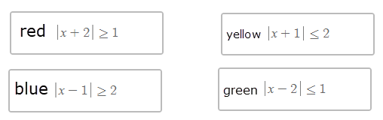
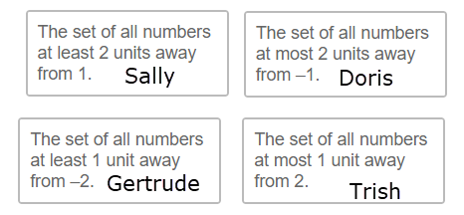 | 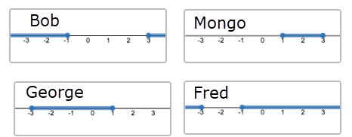

Directions: Determine which woman and what colored vehicle is associated with each man below
Man  Bob | Woman | Man  Fred | Woman | Man  George | Woman | Man  Mongo | Woman
Color | Vehicle | Color | Vehicle | Color | Vehicle | Color | Vehicle

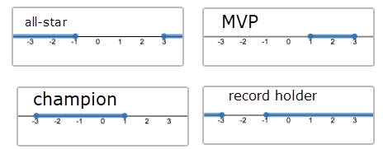 | 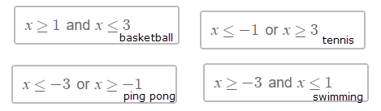
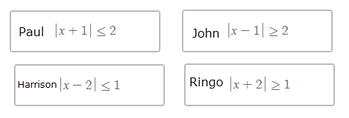 | 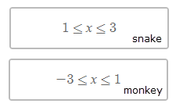

Directions: Determine which person, sport, and animal associated with each title below
Title  All-star | Sport | Title  Champion | Sport | Title  MVP | Sport | Title  Record holder | Sport
Name | Animal  (if possible) | Name | Animal  (if possible) | Name | Animal  (if possible) | Name | Animal  (if possible)

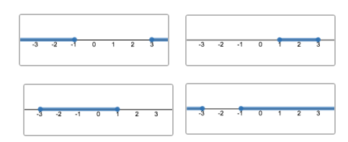 | 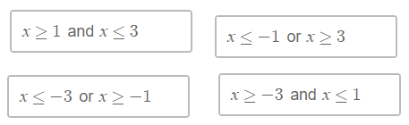
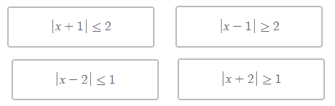 | 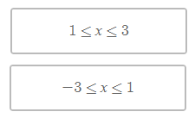

Absolute Value Inequality Card Sort Activity 2 This is a paper-based extension/adaptation of a part of a Desmos Class Activity
Source: https://teacher.desmos.com/dashboard/5ce95b36ede3ee69f744c68d

