Name__________________________________________HWK Basic Functions revisited. Hour________
Parent Linear Function  $$y=x$$ | Parent Quadratic Function  $$y=x^{2}$$ | Parent Cubic Function  $$y=x^{3}$$ | Parent nth power Function  $$y=x^{n}$$
Parent Square Root Function  $$y=\sqrt{x}$$ | Parent Cube Root Function  $$y=\sqrt[3]{x}$$ | Parent nth Root Function  $$y=\sqrt[n]{x}$$ | Parent natural base Function  $$y=e^{x}$$
Parent base 10 Function  $$y={10}^{x}$$ | Parent base b Function  $$y=b^{x}$$ | Parent natural base LOG Function  $$y=ln⁡(x)$$ | Parent common base LOG Function  $$y=\log_{10}{x}$$
Parent base b LOG Function  $$y=\log_{b}{x}$$ | Parent Reciprocal Function  $$y=\frac{1}{x}$$ | Parent Absolute Value Function  $$y=|x|$$ | Parent Greatest Integer Function  $$y=int(x)$$
Parent Logistic Function  $$y=\frac{1}{1+e^{-x}}$$ | Parent Sine Function  $$y=sin⁡(x)$$ | Parent Cosine Function  $$y=cos⁡(x)$$ | Parent Tangent Function  $$y=tan⁡(x)$$

I expanded our list to the TWENTY most basic functions that you would encounter in a PRE-CALCULUS COURSE
Parent Linear Function  $$y=x$$ | Parent Quadratic Function  $$y=x^{2}$$ | Parent Cubic Function  $$y=x^{3}$$
Parent Square Root Function  $$y=\sqrt{x}$$ |  |  | Parent natural base Function  $$y=e^{x}$$
Parent natural base LOG Function
$$y=ln⁡(x)$$
 | Parent Reciprocal Function  $$y=\frac{1}{x}$$ | Parent Absolute Value Function  $$y=|x|$$ | Parent Greatest Integer Function  $$y=int(x)$$
Parent Logistic Function  $$y=\frac{1}{1+e^{-x}}$$ | Parent Sine Function  $$y=sin⁡(x)$$ | Parent Cosine Function  $$y=cos⁡(x)$$

ANSWER the questions below using the NON-highlighted functions first
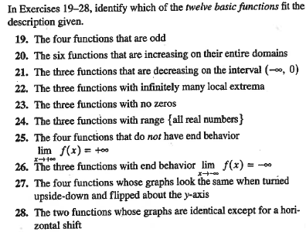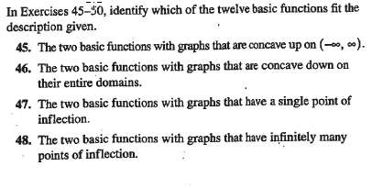

Now investigate the same questions using ONLY the highlighted functions
Parent nth power Function
$$y=x^{n}$$
 | Parent Cube Root Function  $$y=\sqrt[3]{x}$$ | Parent nth Root Function  $$y=\sqrt[n]{x}$$
Parent base 10 Function  $$y={10}^{x}$$ | Parent base b Function  $$y=b^{x}$$ |  | Parent common base LOG Function  $$y=\log_{10}{x}$$
Parent base b LOG Function
$$y=\log_{b}{x}$$

Parent Tangent Function
$$y=tan⁡(x)$$

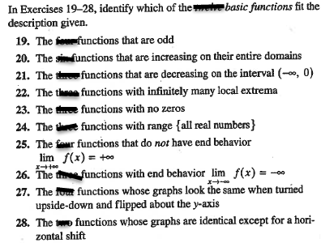
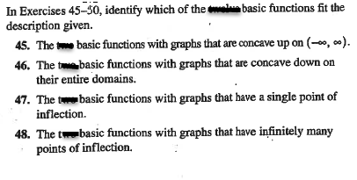DESMOS LINK

