Name________________________________________________ SA Difference Quotient and ROC ALPHA Hour_____
$$f\left(x\right)={3x}^{3}-4x^{2}$$  Use this function to answer the questions on this page.  - Determine the slope of the secant line from x = 2 to x = 3  SHOW DIFFERENCE QUOTIENT  - Write the equation of the secant line from x = 2 to x = 3  (CALCULUS DOES NOT USUALLY CARE ABOUT Y INTERCEPT, so use modified point slope format)  - Determine the average rate of change (AROC) from x = 2 to x = 3  SHOW DIFFERENCE QUOTIENT | 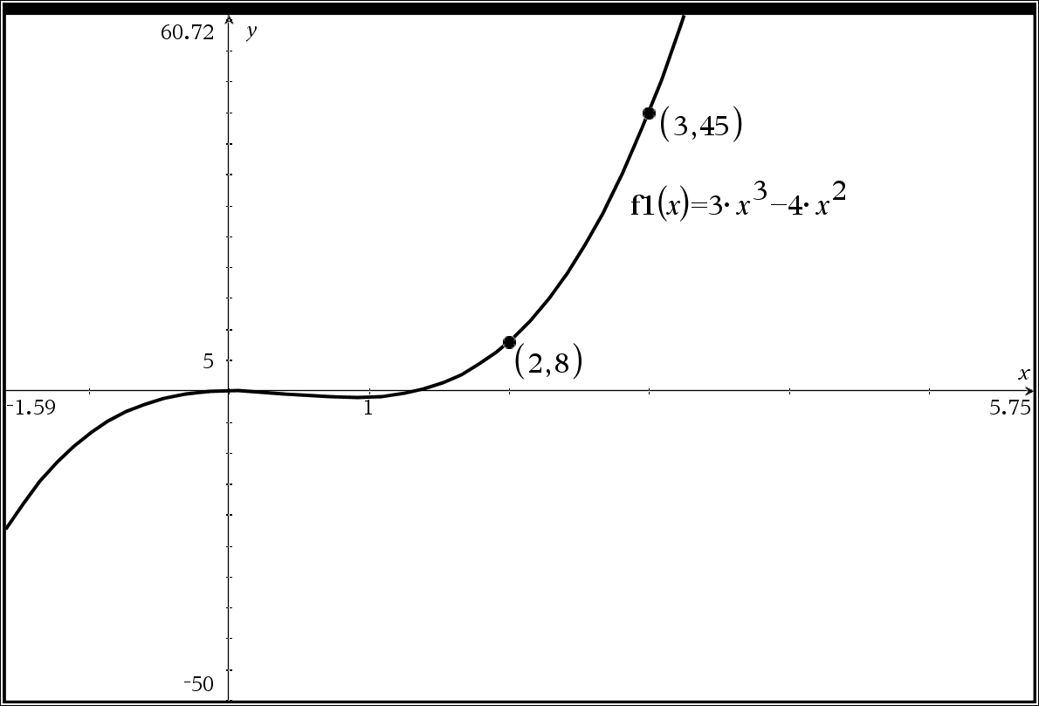  - Use x = 1.9999 and x = 2 to APPROXIMATE the instantaneous rate of at x = 2  SHOW DIFFERENCE QUOTIENT  - Use x = 2.0001 and x = 2 to APPROXIMATE the instantaneous rate of at x = 2  SHOW DIFFERENCE QUOTIENT  - What did #4 and #5 suggest as the APPROXIMATE slope of the tangent line?  - Write the equation of APPROXIMATE tangent line at  x = 2
EC: You will receive a bonus point on this assessment IF all digital requirements on Desmos Teacher have been met by Sunday!
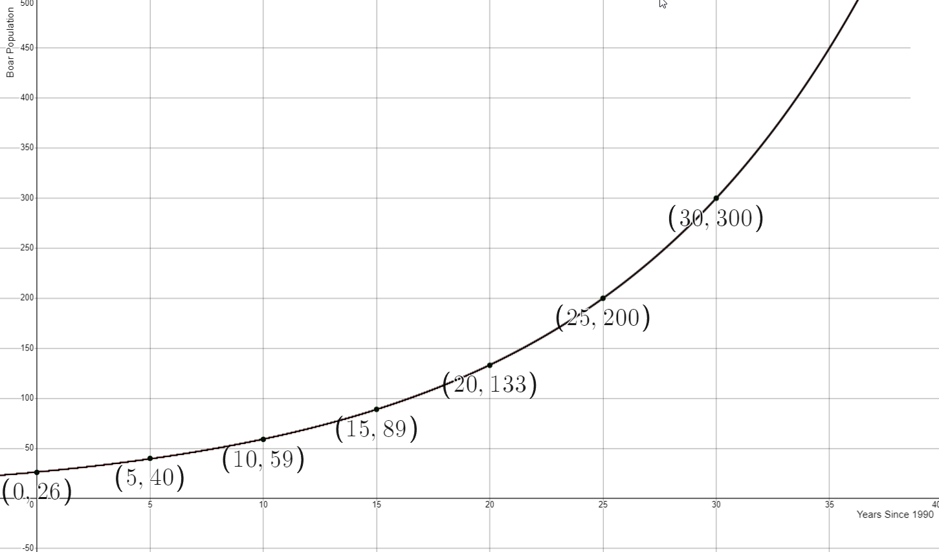 | Use this graph and the given information below to answer the questions below.  The population of a community of wild boar is modeled by the function b, where b(x) gives the number of boar and x gives the number of years since 1990 for $0≤x≤30$ years

- Sketch the tangent line at x = 20 years after 1990. DO THIS ON THE GRAPH ITSELF!

- Using the given graph and the related points, give a rough estimate of the instantaneous rate of change at x = 20 years. Give a related difference quotient based on this rough estimate.

- Give a related difference quotient of a better approximation for b(x) IF YOU KNEW the function for b(x)!

- Suppose that you knew that this f(x) was, in fact, $b\left(x\right)=26.3374{(1.08447)}^{x}$ with x measured in years and b(x) measured in meters. Give a better estimate of the instantaneous rate of change at x = 20 years.
Give a related difference quotient based on this rough estimate.

The number of jobs created in the U.S. for the 2021 economy can be modeled by J, where J(m) is the number of new jobs and m is the month in 2021 for $0≤m≤12$
- What does J(3) represent? (hint: a specific month should be mentioned in the best explanation)

- What does $\frac{J\left(8\right)-J(3)}{8-3}$ represent? Be specific and use units!

- What does $\frac{J\left(9\right)-J(8.9999)}{9-8.9999}$ represent? Be specific and use units!

EC: If you could improve one thing about yourself, what would it be and why?
Name________________________________________________ SA Difference Quotient and ROC BETA Hour_____
$$f\left(x\right)={-5x}^{3}-9x^{2}$$  Use this function to answer the questions on this page.  - Determine the slope of the secant line from x = 1 to x = 2  SHOW DIFFERENCE QUOTIENT  - Write the equation of the secant line from x = 1 to x = 2  (CALCULUS DOES NOT USUALLY CARE ABOUT Y INTERCEPT, so use modified point slope format)  - Determine the average rate of change (AROC) from x = 1 to x = 2  SHOW DIFFERENCE QUOTIENT | 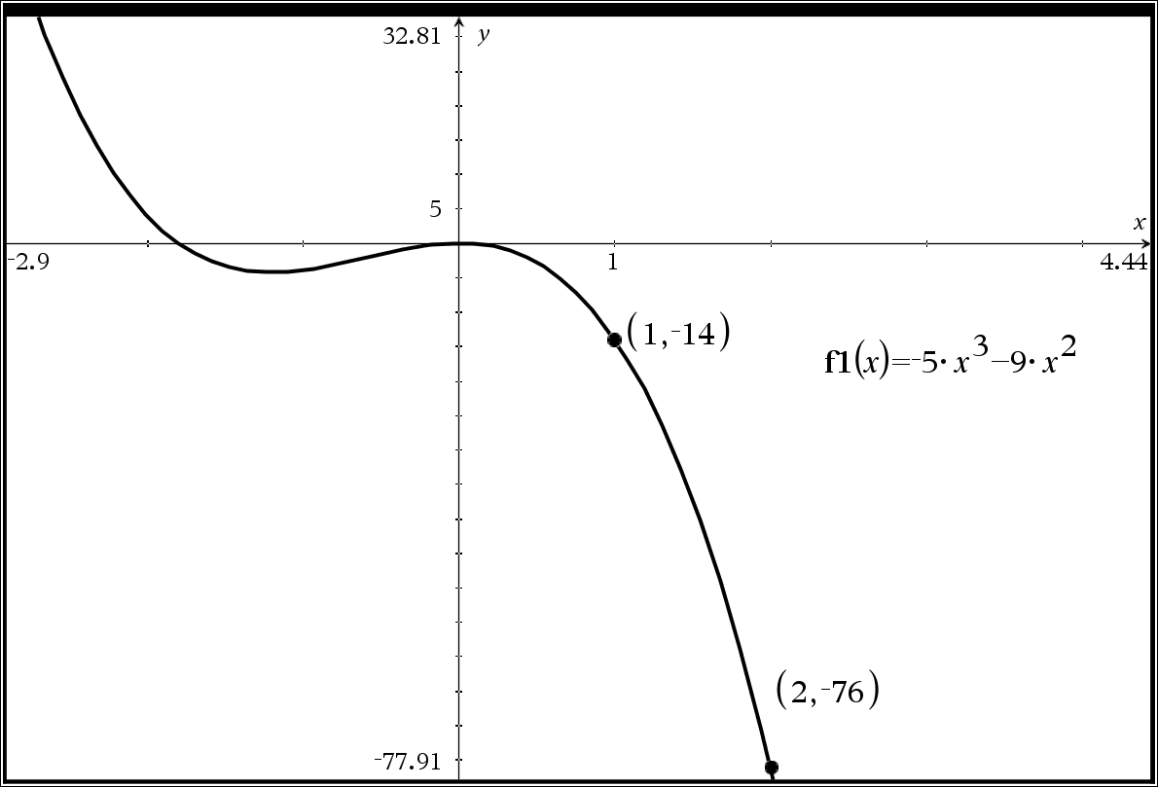  - Use x = 1.9999 and x = 2 to APPROXIMATE the instantaneous rate of at x = 2  SHOW DIFFERENCE QUOTIENT  - Use x = 2.0001 and x = 2 to APPROXIMATE the instantaneous rate of at x = 2  SHOW DIFFERENCE QUOTIENT  - What did #4 and #5 suggest as the APPROXIMATE slope of the tangent line?  - Write the equation of APPROXIMATE tangent line at  x = 2
EC: You will receive a bonus point on this assessment IF all digital requirements on Desmos Teacher have been met by Sunday!
Use this graph and the given information below to answer the questions below.

The population of a community of wild boar is modeled by the function b, where b(x) gives the number of boar and x gives the number of years since 1990 for $0≤x≤30$ years

- Sketch the tangent line at x = 15 years after 1990. DO THIS ON THE GRAPH ITSELF!

- Using the given graph and the related, points give a rough estimate of the instantaneous rate of change at x = 15 years. Give a related difference quotient based on this rough estimate.

- Give a related difference quotient of a better approximation for b(x) IF YOU KNEW the function for b(x)!

- Suppose that you knew that this f(x) was, in fact, $b\left(x\right)=26.3374{(1.08447)}^{x}$ with x measured in years and b(x) measured in meters. Give a better estimate of the instantaneous rate of change at x = 15 years.
Give a related difference quotient based on this rough estimate.

A hurricane has formed in the Atlantic Ocean and is headed for Miami. It’s distance from Miami can be modeled D, where D(t) is the number of miles from Miami and t is the hours since Monday Morning for $0≤t≤96$
- What does D(50) represent? (hint: a specific hour should be mentioned in the best explanation)

- What does $\frac{D\left(40\right)-D(30)}{40-30}$ represent? Be specific and use units!

- What does $\frac{D\left(18\right)-D(17.9999)}{18-17.9999}$ represent? Be specific and use units!

EC: If you could improve one thing about yourself, what would it be and why?
Name________________________________________________ SA Difference Quotient and ROC DELTA Hour_____
$$f\left(x\right)={-2x}^{3}-5x^{2}$$  Use this function to answer the questions on this page.  - Determine the slope of the secant line from x = 1 to x = 2  SHOW DIFFERENCE QUOTIENT  - Write the equation of the secant line from x = 1 to x = 2  (CALCULUS DOES NOT USUALLY CARE ABOUT Y INTERCEPT, so use modified point slope format)  - Determine the average rate of change (AROC) from x = 1 to x = 2  SHOW DIFFERENCE QUOTIENT | 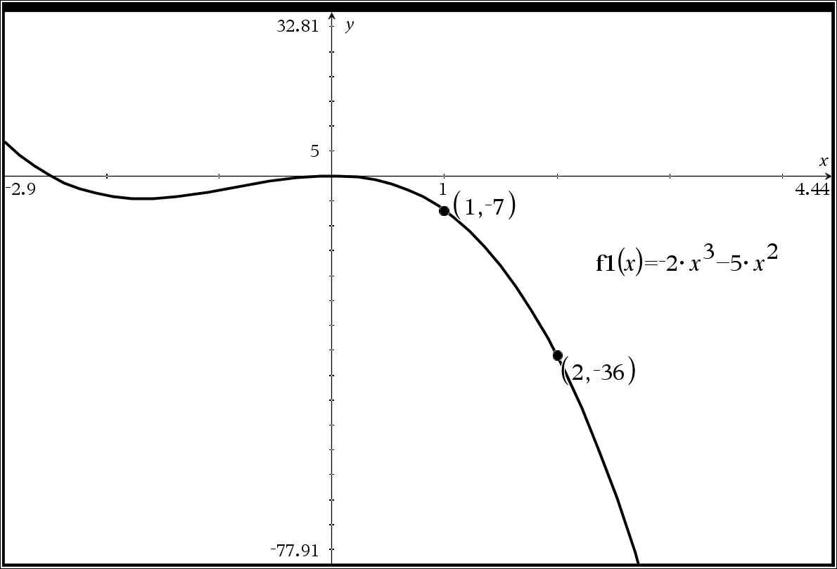  - Use x = 0.9999 and x = 1 to APPROXIMATE the instantaneous rate of at x = 1  SHOW DIFFERENCE QUOTIENT  - Use x = 1.0001 and x = 1 to APPROXIMATE the instantaneous rate of at x = 1  SHOW DIFFERENCE QUOTIENT  - What did #4 and #5 suggest as the APPROXIMATE slope of the tangent line?  - Write the equation of APPROXIMATE tangent line at  x = 1
EC: You will receive a bonus point on this assessment IF all digital requirements on Desmos Teacher have been met by Sunday!
Use this graph and the given information below to answer the questions below.

The population of a community of wild boar is modeled by the function b, where b(x) gives the number of boar and x gives the number of years since 1990 for $0≤x≤30$ years

- Sketch the tangent line at x = 25 years after 1990. DO THIS ON THE GRAPH ITSELF!

- Using the given graph and the related points, give a rough estimate of the instantaneous rate of change at x = 25 years. Give a related difference quotient based on this rough estimate.

- Give a related difference quotient of a better approximation for b(x) IF YOU KNEW the function for b(x)!

- Suppose that you knew that this f(x) was, in fact, $b\left(x\right)=26.3374{(1.08447)}^{x}$ with x measured in years and b(x) measured in meters. Give a better estimate of the instantaneous rate of change at x = 25 years.
Give a related difference quotient based on this rough estimate.

The number of people enlisting in the army each year can be modeled by E, where E(t) is the number of new recruits and t is the years since 1980 for $0≤t≤20$
- What does E(9) represent? (hint: a specific year should be mentioned in the best explanation)

- What does $\frac{E\left(10\right)-E(4)}{10-4}$ represent? Be specific and use units!

- What does $\frac{E\left(11\right)-E(10.9999)}{11-10.9999}$ represent? Be specific and use units!

EC: If you could improve one thing about yourself, what would it be and why?
$$f\left(x\right)={2x}^{2}-4x$$
How do I get the difference quotient on TI Nspire?  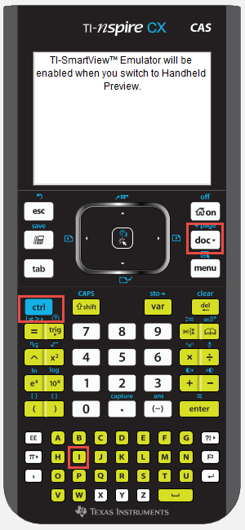  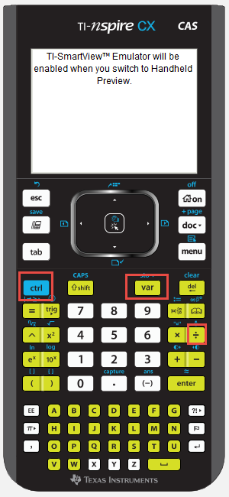 | Difference quotient  Note: this is the difference quotient $\frac{f\left(x_{2}\right)-f\left(x_{1}\right)}{x_{2}-x_{1}}$  In previous classes, we called this SLOPE, in upper-level classes leading to CALCULUS, we use the fancier term, but it is all still about SLOPE or Rate of Change.  On the TI Nspire, it should be $\frac{f_{1}\left(x_{2}\right)-f_{1}\left(x_{1}\right)}{x_{2}-x_{1}}$  Option 1:  - Define your function on Graphs page.  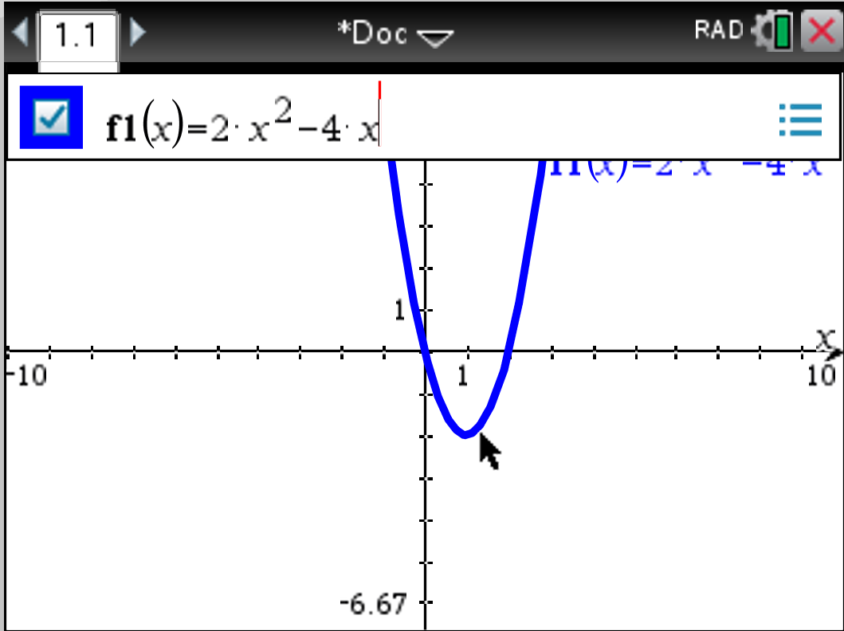  - Add a calculator page (Press CTRL i, or press DOC button and INSERT PAGE)  This is CTRL i path or CTRL DOC Button path This is DOC Button path  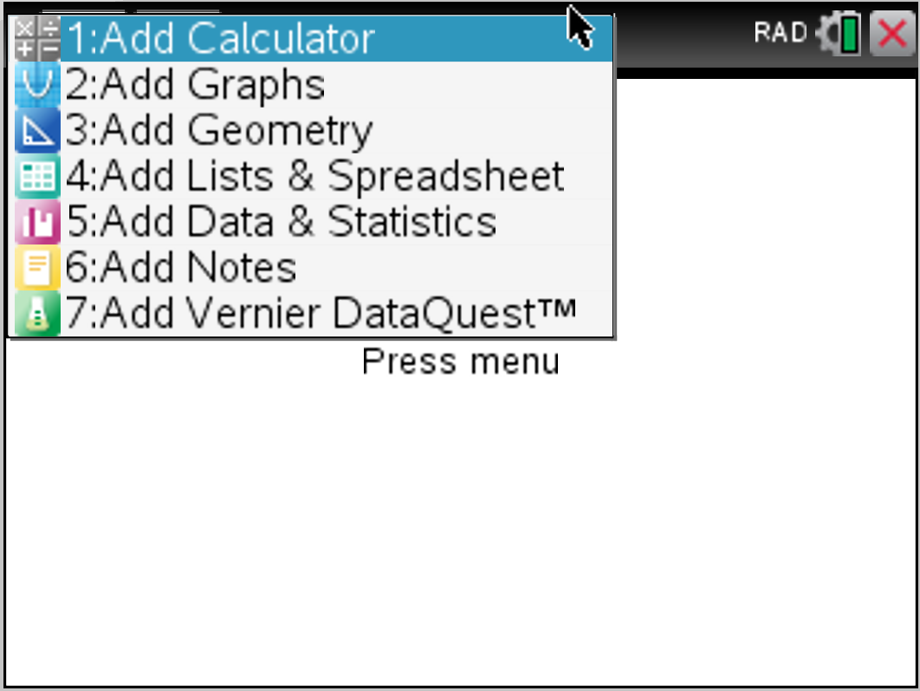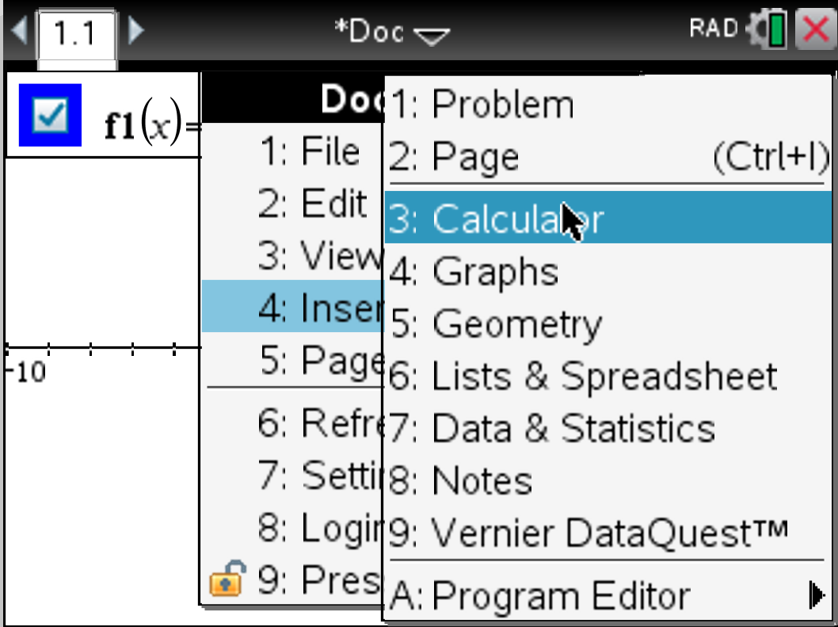  - Press CTRL / button to insert a fraction  - Press VAR button (faster method) or type f1() using keystrokes (slower method) directly to create difference quotient  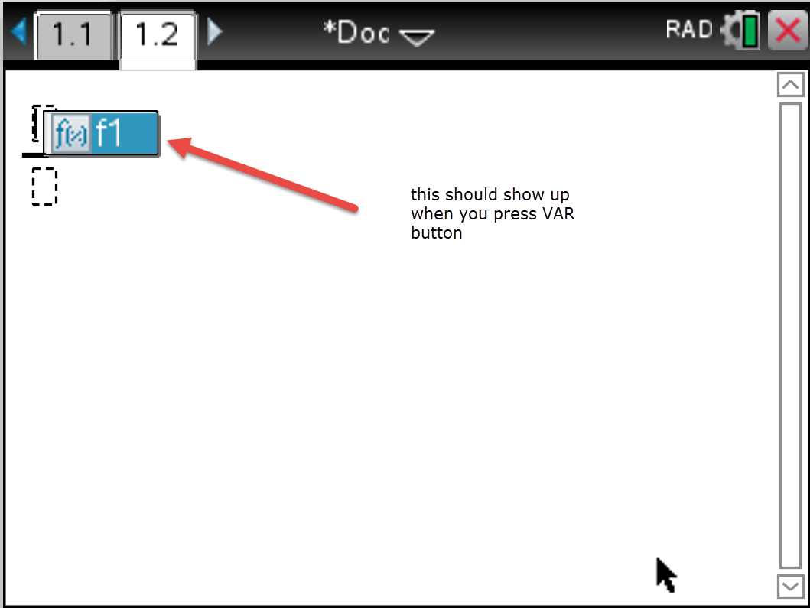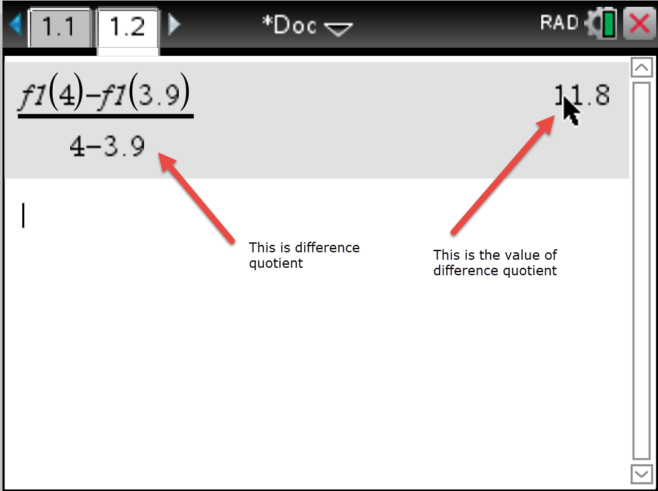

How do I get the difference quotient on TI Nspire?  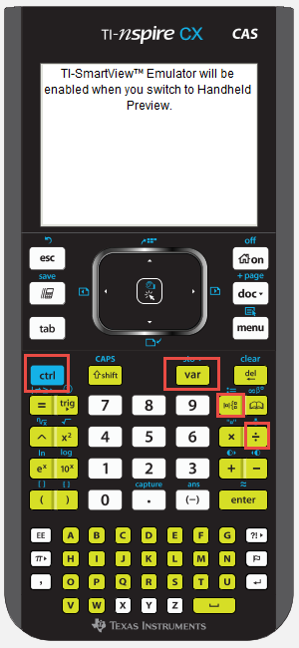 | Difference quotient  Note: this is the difference quotient $\frac{f\left(x_{2}\right)-f\left(x_{1}\right)}{x_{2}-x_{1}}$  In previous classes, we called this SLOPE, in upper-level classes leading to CALCULUS, we use the fancier term, but it is all still about SLOPE or Rate of Change.  On the TI Nspire, it should be $\frac{f_{1}\left(x_{2}\right)-f_{1}\left(x_{1}\right)}{x_{2}-x_{1}}$  Option 2:  - Add a calculator page (Press CTRL i, or press DOC button and INSERT PAGE)  This is CTRL i path or CTRL DOC Button path This is DOC Button path  - Define your function using := button (this is CTRL and the button immediately to the RIGHT of the 9 button (you know it worked if it says DONE)  - Press CTRL / button to insert a fraction.  - Press VAR button (faster method) or type f1() using keystrokes (slower method) directly to create difference quotient  