Name________________________________________________ RR Difference Quotient and ROC ALL Hour_____
$$f\left(x\right)={-2x}^{3}+5x^{2}$$  Use this function to answer the questions on this page.  - Determine the slope of the secant line from x = 3 to x = 4  SHOW DIFFERENCE QUOTIENT  - Write the equation of the secant line from x = 3 to x = 4  (CALCULUS DOES NOT USUALLY CARE ABOUT Y INTERCEPT, so use modified point slope format)  - Determine the average rate of change (AROC) from x = 3 to x = 4  SHOW DIFFERENCE QUOTIENT | 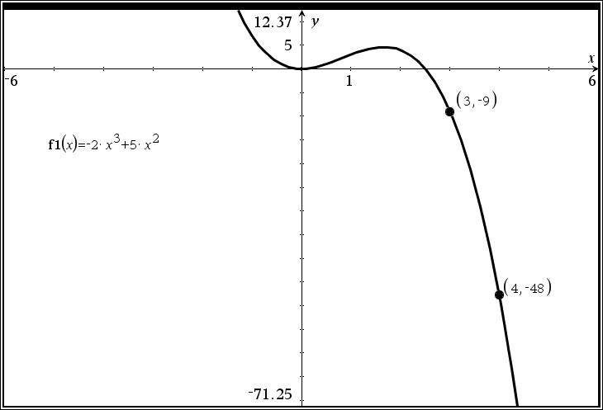  - Use x = 3.9999 and x = 4 to APPROXIMATE the instantaneous rate of at x = 4  SHOW DIFFERENCE QUOTIENT  - Use x = 4.0001 and x = 4 to APPROXIMATE the instantaneous rate of at x = 4  SHOW DIFFERENCE QUOTIENT  - What did #4 and #5 suggest as the APPROXIMATE slope of the tangent line?  - Write the equation of APPROXIMATE tangent line at  x = 4
EC: You will receive a bonus point on this assessment IF all digital requirements on Desmos Teacher have been met by Sunday!
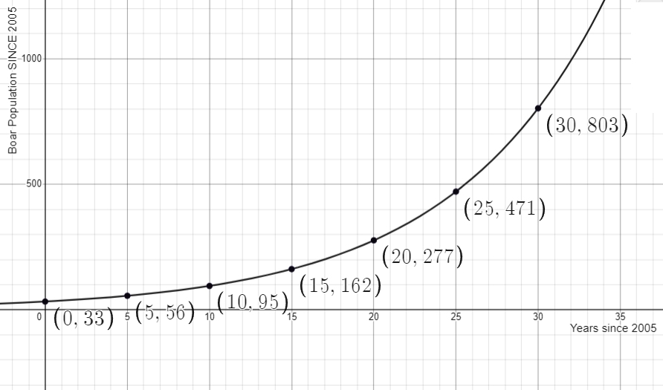 | Use this graph and the given information below to answer the questions below.  The population of a community of wild boar is modeled by the function b, where b(x) gives the number of boar and x gives the number of years since 2005 for $0≤x≤30$ years

- Sketch the tangent line at x = 20 years after 2005. DO THIS ON THE GRAPH ITSELF!

- Using the given graph and the related points, give a rough estimate of the instantaneous rate of change at x = 20 years. Give a related difference quotient based on this rough estimate.

- Give a related difference quotient of a better approximation for b(x) IF YOU KNEW the function for b(x)!

- Suppose that you knew that this f(x) was, in fact, $b\left(x\right)=32.8245{(1.11245)}^{x}$ with x measured in years and b(x) measured in meters. Give a better estimate of the instantaneous rate of change at x = 20 years.
Give a related difference quotient based on this rough estimate.

The number of jobs lost in the U.S. for the 2020 economy can be modeled by J, where J(m) is the number of lost jobs and m is the month in 2020 for $0≤m≤12$
- What does J(7) represent? (hint: a specific month should be mentioned in the best explanation)

- What does $\frac{J\left(9\right)-J(3)}{9-3}$ represent? Be specific and use units!

- What does $\frac{J\left(10\right)-J(9.9999)}{10-9.9999}$ represent? Be specific and use units!

EC: If you could improve one thing about yourself, what would it be and why?

