Name________________________________________________ Sample Quiz Difference Quotient and ROC Hour_____
$$f\left(x\right)={2x}^{2}-4x$$  Use this function to answer the questions on this page.  - Determine the slope of the secant line from x = 3 to x = 4  SHOW DIFFERENCE QUOTIENT  - Write the equation of the secant line from x = 3 to x = 4  (CALCULUS DOES NOT USUALLY CARE ABOUT Y INTERCEPT, so use modified point slope format)  - Determine the average rate of change (AROC) from x = 3 to x = 4  SHOW DIFFERENCE QUOTIENT | 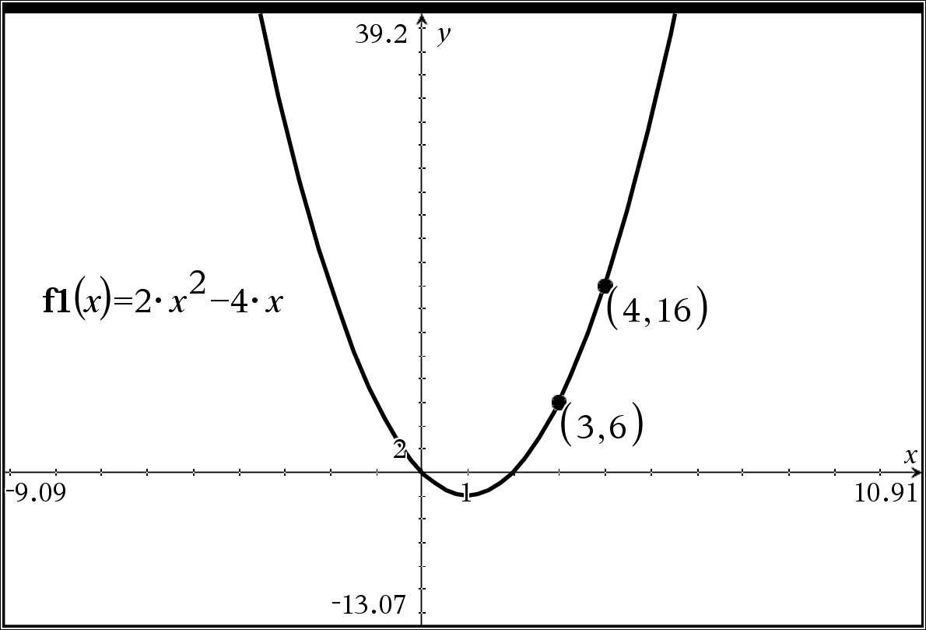  - Use x = 3.9999 and x = 4 to APPROXIMATE the instantaneous rate of at x = 4  SHOW DIFFERENCE QUOTIENT  - Use x = 4.0001 and x = 4 to APPROXIMATE the instantaneous rate of at x = 4  SHOW DIFFERENCE QUOTIENT  - What did #4 and #5 suggest as the APPROXIMATE slope of the tangent line?  - Write the equation of APPROXIMATE tangent line at  x = 4

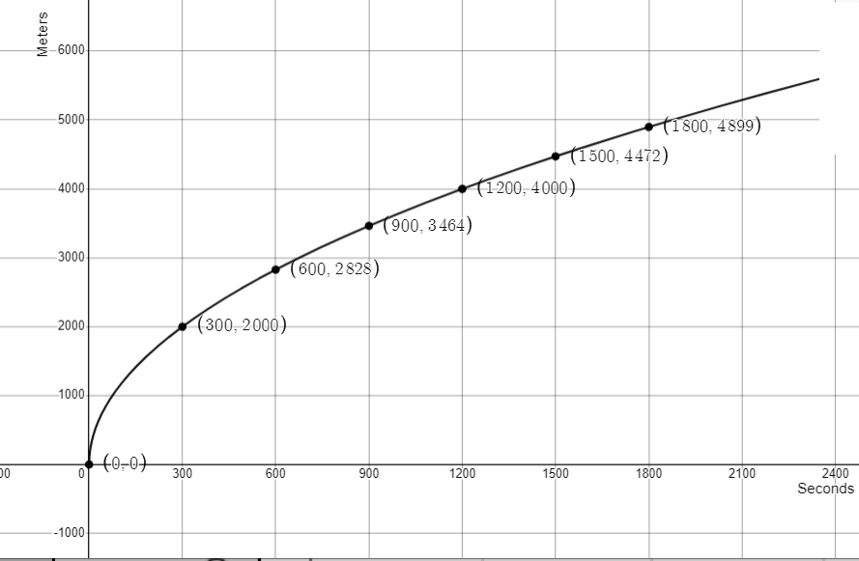 | Use this graph and the given information below to answer the questions below.  A jogger’s distance whole on a run can be modeled by the function depicted on the given graph. f(x) gives the distance the jogger has ran in meters and x gives the number of seconds the jogger has been running for $0≤x≤1800$ seconds

- Sketch the tangent line at x = 600 seconds. DO THIS ON GRAPH ITSELF!

- Using the given graph and the related points give a rough estimate of the instantaneous rate of change at x = 600 seconds. Give a related difference quotient based on this rough estimate.

- Give a related difference quotient of a better approximation for f(x) IF YOU KNEW the function for f(x)!

- Suppose that you knew that this f(x) was, in fact, $f\left(x\right)=115.47\sqrt{x}$ with x measured in seconds and f(x) measured in meters. Give a better estimate of the instantaneous rate of change at x = 600 seconds.
Give a related difference quotient based on this rough estimate.

The number of graduating seniors at a high schools can be modeled by G, where G(t) is the number of graduating seniors and t is the year since 2005 for $0≤t≤25$
- What does G(6) represent? (hint: a 4 digit year should be mentioned in the best explanation)

- What does $\frac{G\left(6\right)-G(1)}{6-1}$ represent? Be specific!

- What does $\frac{G\left(6\right)-G(5.9999)}{6-5.9999}$ represent? Be specific!

$$f\left(x\right)={2x}^{2}-4x$$
How do I get the difference quotient on TI Nspire?  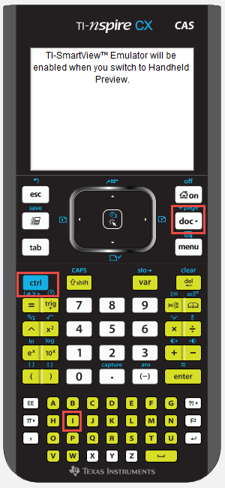  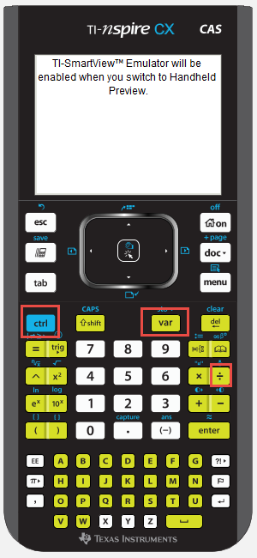 | Difference quotient  Note: this is the difference quotient $\frac{f\left(x_{2}\right)-f\left(x_{1}\right)}{x_{2}-x_{1}}$  In previous classes, we called this SLOPE, in upper-level classes leading to CALCULUS, we use the fancier term, but it is all still about SLOPE or Rate of Change.  On the TI Nspire, it should be $\frac{f_{1}\left(x_{2}\right)-f_{1}\left(x_{1}\right)}{x_{2}-x_{1}}$  Option 1:  - Define your function on Graphs page.  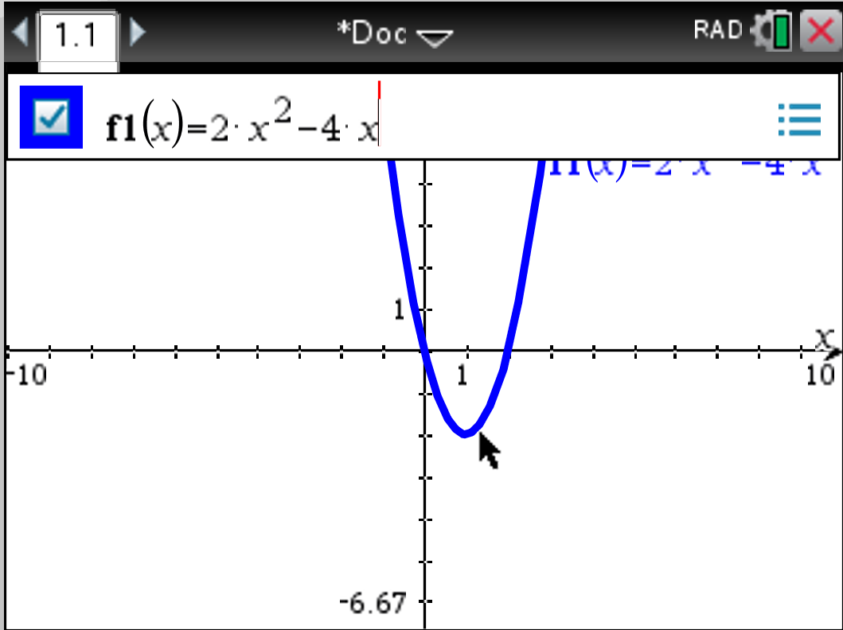  - Add a calculator page (Press CTRL i, or press DOC button and INSERT PAGE)  This is CTRL i path or CTRL DOC Button path This is DOC Button path  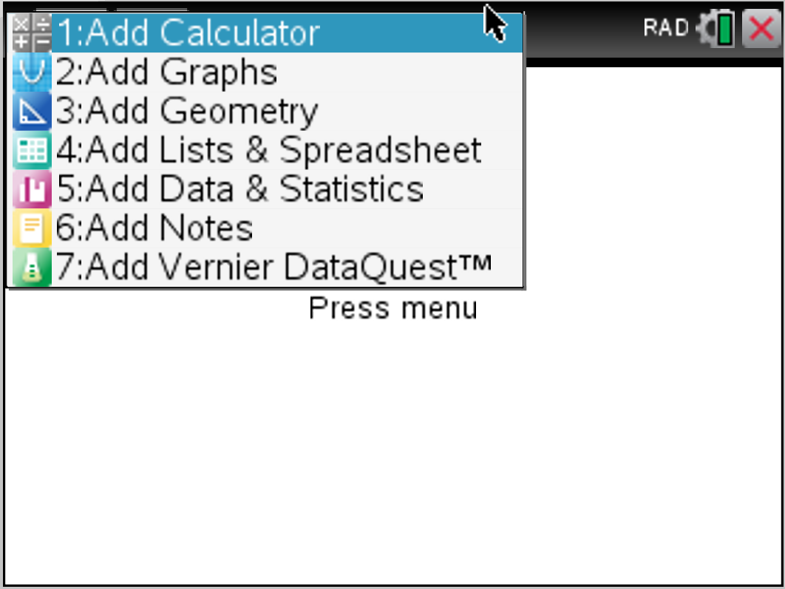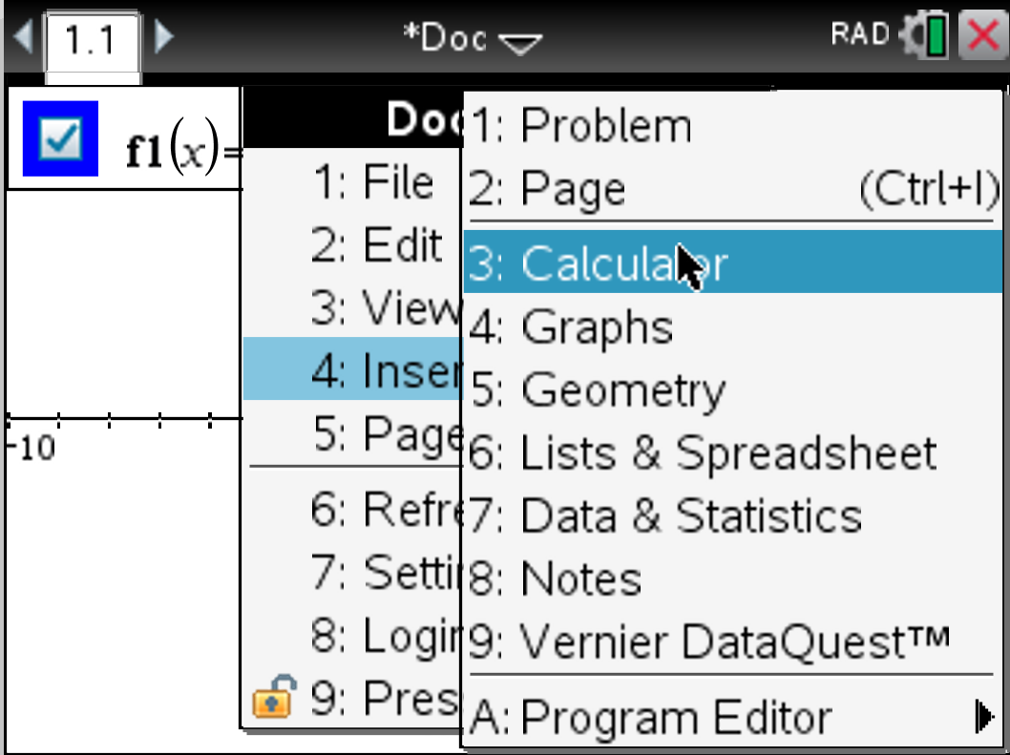  - Press CTRL / button to insert a fraction  - Press VAR button (faster method) or type f1() using keystrokes (slower method) directly to create difference quotient  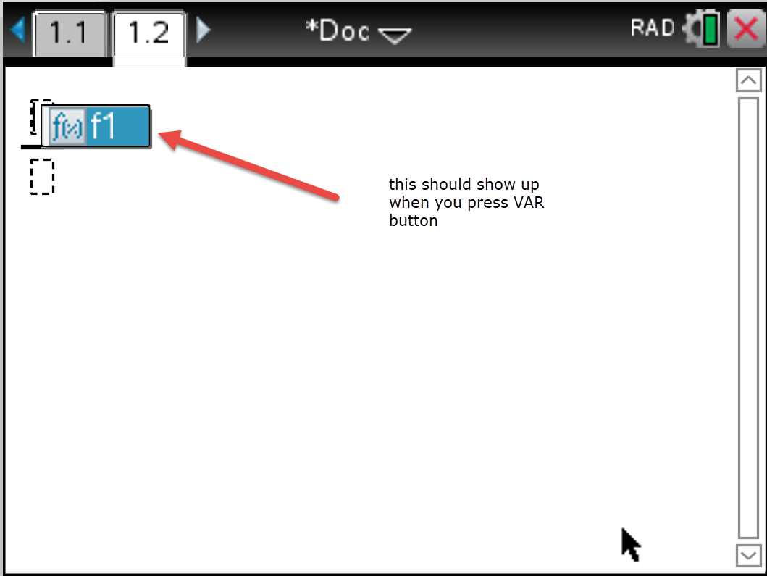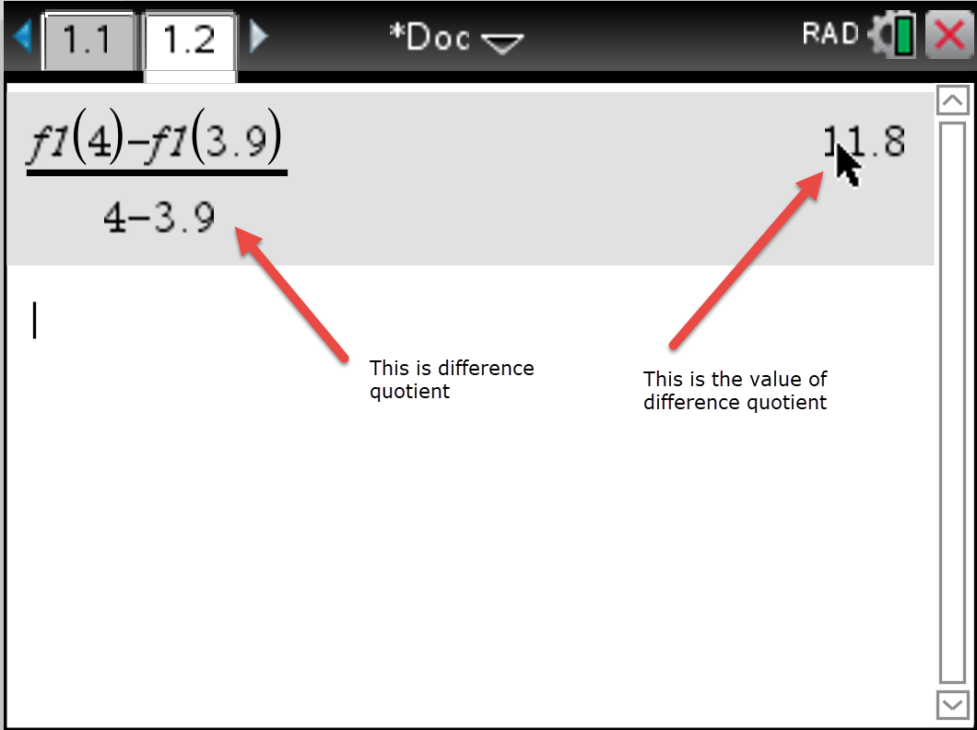

How do I get the difference quotient on TI Nspire?  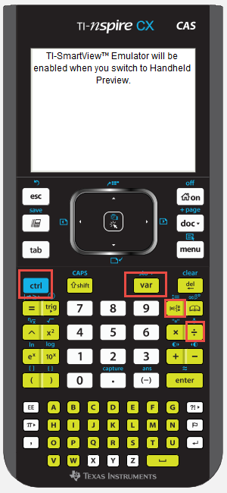 | Difference quotient  Note: this is the difference quotient $\frac{f\left(x_{2}\right)-f\left(x_{1}\right)}{x_{2}-x_{1}}$  In previous classes, we called this SLOPE, in upper-level classes leading to CALCULUS, we use the fancier term, but it is all still about SLOPE or Rate of Change.  On the TI Nspire, it should be $\frac{f_{1}\left(x_{2}\right)-f_{1}\left(x_{1}\right)}{x_{2}-x_{1}}$  Option 2:  - Add a calculator page (Press CTRL i, or press DOC button and INSERT PAGE)  This is CTRL i path or CTRL DOC Button path This is DOC Button path  - Define your function using := button (this is CTRL and the button immediately to the RIGHT of the 9 button (you know it worked if it says DONE)  - Press CTRL / button to insert a fraction.  - Press VAR button (faster method) or type f1() using keystrokes (slower method) directly to create difference quotient  