Name__________________________Formative Solving Logarithmic Equations Period_____
- ALGEBRAICALLY determine the solutions to the given logarithmic equations
- CONFIRM answers using a graphing calculator
- Complete the related table
Related Graph  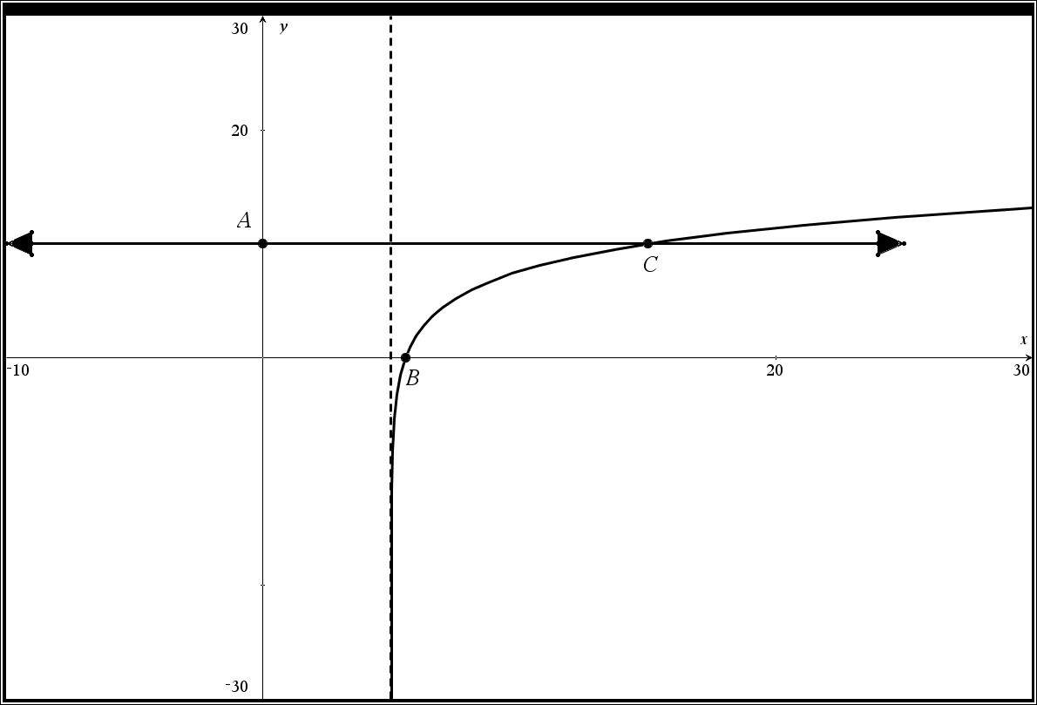 | Related Equation  $${8log}_{10}{(x-5)}+2= 10$$

Did you have any extraneous solutions? _______ If so what was it?_________
Related Functions  $$f\left(x\right)={8log}_{10}\left(x-5\right)+2$$  $$g\left(x\right)=10$$ | State the coordinate A  Exact  Approximate | State the coordinate B  Exact  Approximate | State the coordinate C  Exact  Approximate | State the Domain of the Logarithmic Function  State the vertical asymptote

Solve each of the following logarithmic equations
$$\log_{8}\left(x-10\right)+\log_{8}\left(x+10\right)=2$$  Did you have any extraneous solutions? _______  If so what was it?_________ | $$\log_{6}\left(x-1\right)+\log_{6}\left(x+9\right)=\log_{6}\left(11\right)$$  Did you have any extraneous solutions? _______  If so what was it?_________

Name__________________________Formative Solving Logarithmic Equations Period_____
- ALGEBRAICALLY determine the solutions to the given logarithmic equations
- CONFIRM answers using a graphing calculator
- Complete the related table
Related Graph  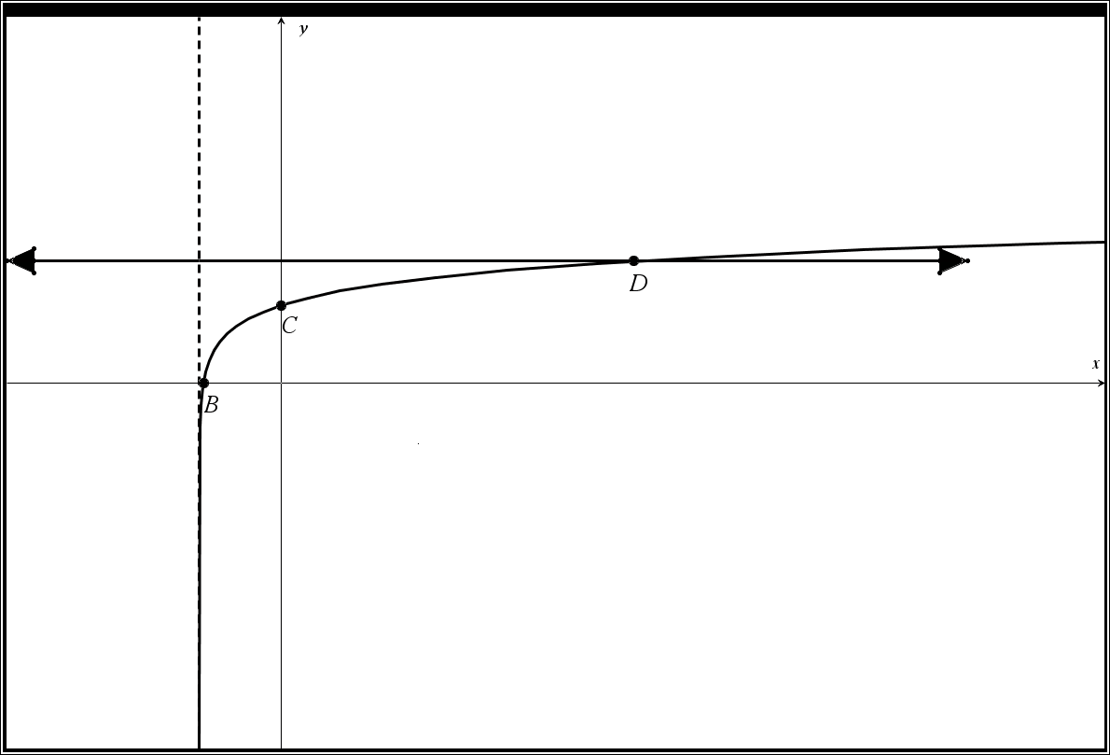 | Related Equation  $${5log}_{10}{(x+3)}+4= 14$$

Did you have any extraneous solutions? _______ If so what was it?_________
Related Functions  $$f\left(x\right)={5log}_{10}{(x+3)}+4$$  $$g\left(x\right)=10$$  State the Domain of the Logarithmic Function  State the vertical asymptote | State the coordinate A  Exact  Approximate | State the coordinate B  Exact  Approximate | State the coordinate C  Exact  Approximate | State the coordinate D  Exact  Approximate
Solve each of the following logarithmic equations
$$\log_{4}\left(x-10\right)+\log_{4}\left(x+10\right)=3$$  Did you have any extraneous solutions? _______  If so what was it?_________ | $$\log_{6}\left(x-1\right)+\log_{6}\left(x+10\right)=\log_{6}\left(12\right)$$  Did you have any extraneous solutions? _______  If so what was it?_________

