Name________________________________Summative Assessment Exponential Equations and Systems Period ____
SHOW ALL OF YOUR WORK IN A CLEAR AND EASY TO FOLLOW MANNER
Give an exact and approximate answer when necessary (attempt this problem WITHOUT the use of LOG)
- $5∙2^{4x-3}-8=312$

Graph of the related system  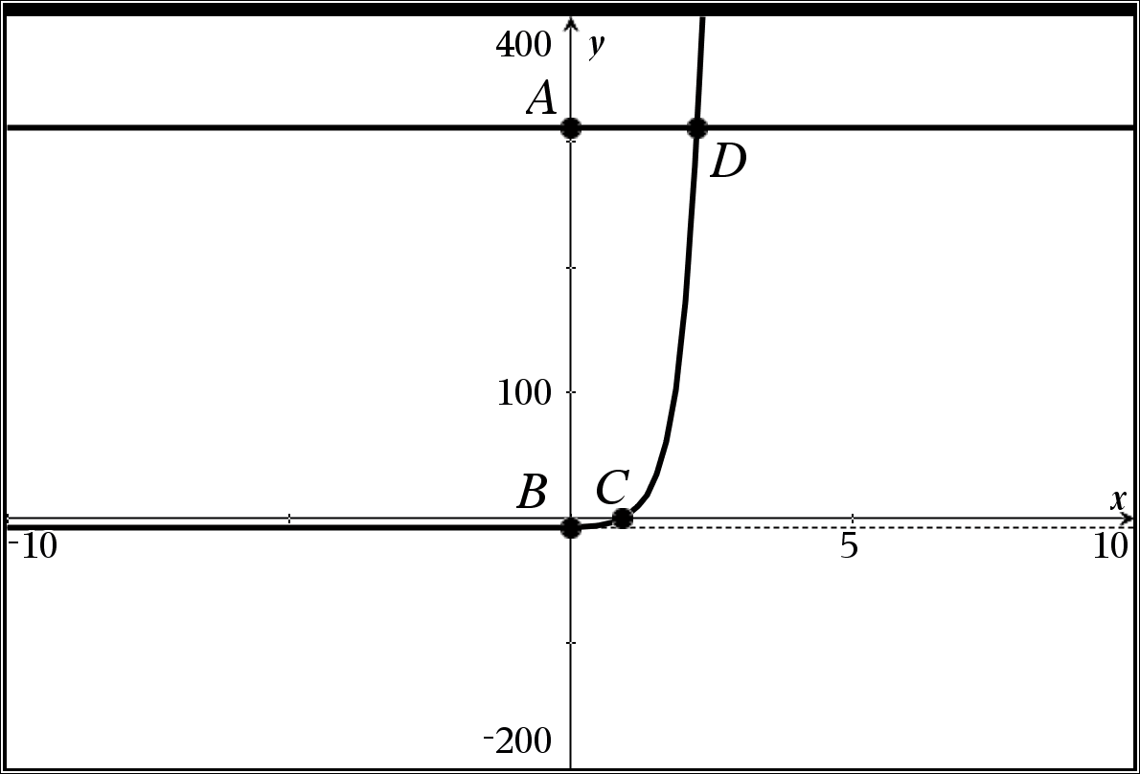 | Graph of the related system  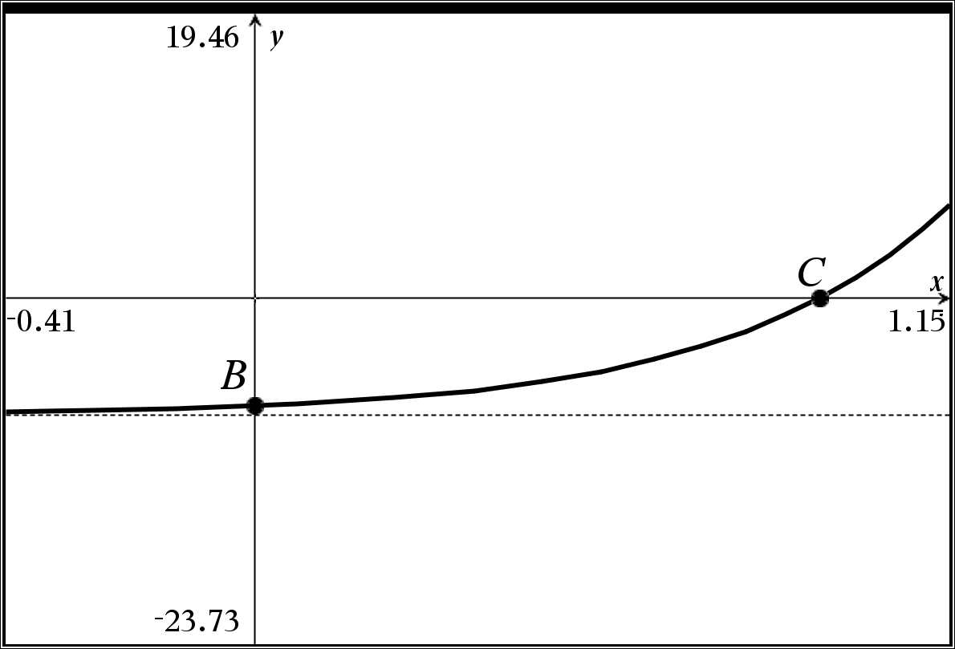
- Show the ALGEBRA necessary to find point C

- Complete the related table
Point A | Point B | Point C | Point D | Horizontal Asymptote
 | Exact  Approximate | Exact  Approximate | Exact  Approximate

Give an exact and approximate answer when necessary (You will need the use of a logarithm for this problem)
- $-2∙3^{-2x+1}-1=-17$

Graph of the related system  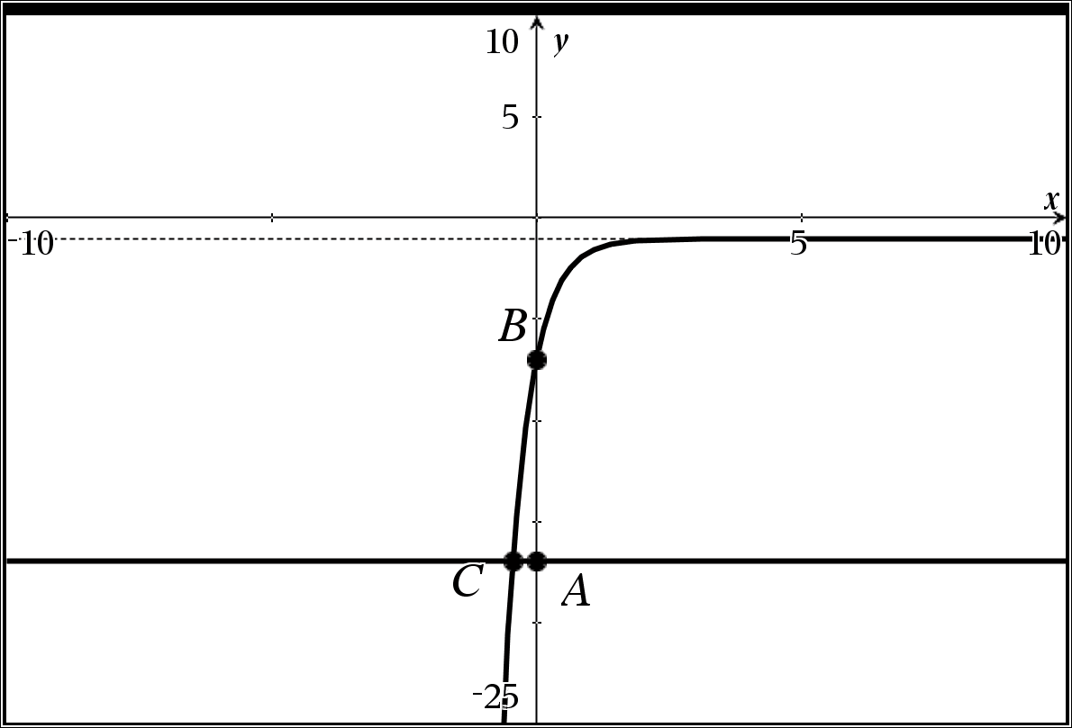 | Graph of the related system  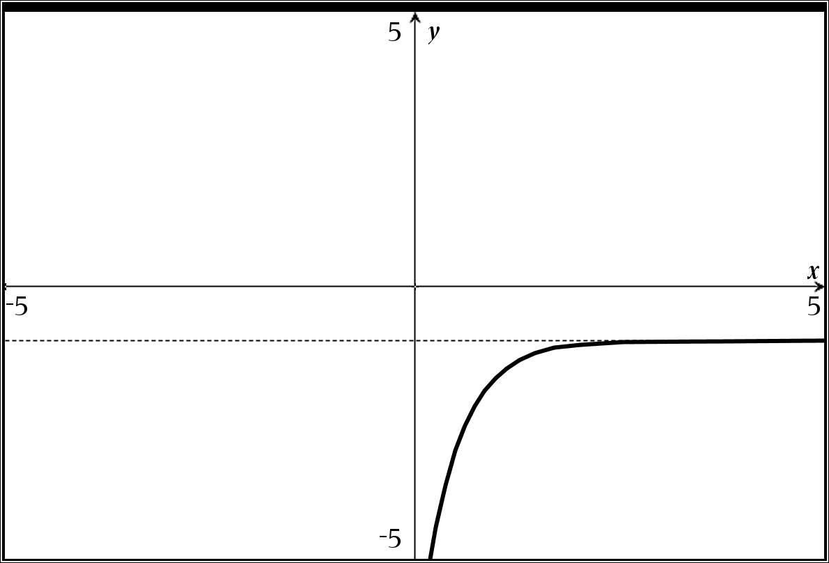

- Complete the related table
Point A | Point B | Point C | Horizontal Asymptote
 | Exact  Approximate | Exact  Approximate

Extra Credit 1: Give an example of how you intend to keep your mind active over the summer

Give an exact and approximate answer when necessary (You will need the use of a logarithm for this problem)
- $4∙{10}^{-x+1}=20$

Graph of the related system
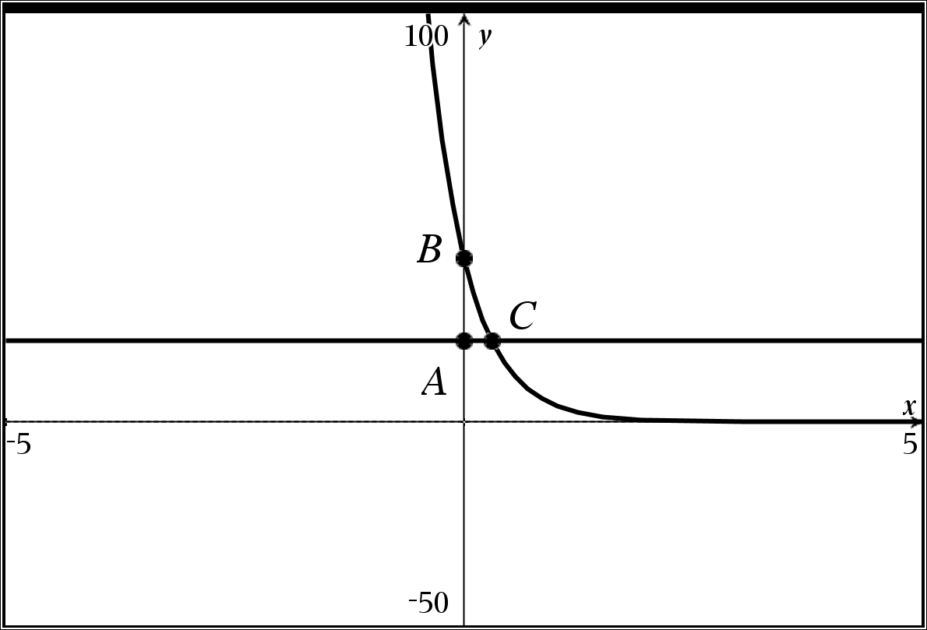
- Complete the related table
Point A | Point B | Point C | Horizontal Asymptote
 | Exact  Approximate | Exact  Approximate

Extra Credit #2: Which better describes your next step in mathematics and why? Exciting Scary

Give an exact and approximate answer when necessary (You will need the use of a logarithm for this problem)
- $\frac{1}{2}∙e^{2x-6}+5=25$

Graph of the related system
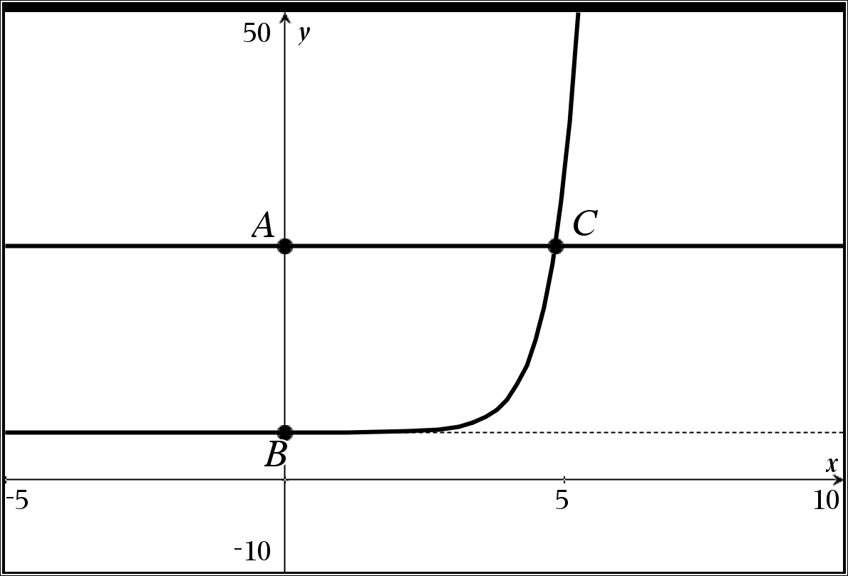
- Complete the related table
Point A | Point B | Point C | Horizontal Asymptote
 | Exact  Approximate | Exact  Approximate

Extra Credit #3 If you could thank only one teacher for what they have done for you this year, what would it be for?

Name________________________________Summative Assessment Exponential Equations and Systems Period ____
SHOW ALL OF YOUR WORK IN A CLEAR AND EASY TO FOLLOW MANNER
Give an exact and approximate answer when necessary (attempt this problem WITHOUT the use of LOG)
- $11∙3^{5x-2}-7=92$

Graph of the related system  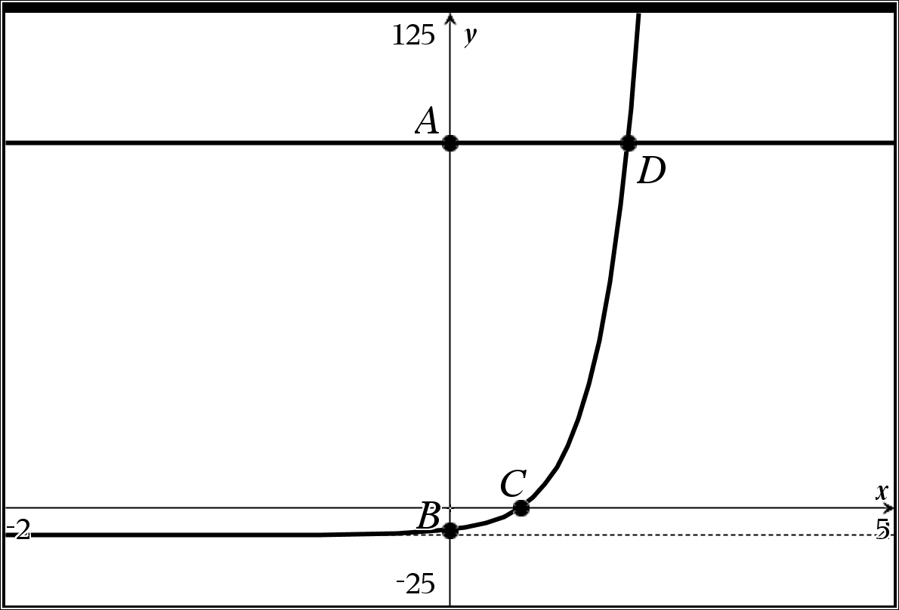 | Graph of the related system  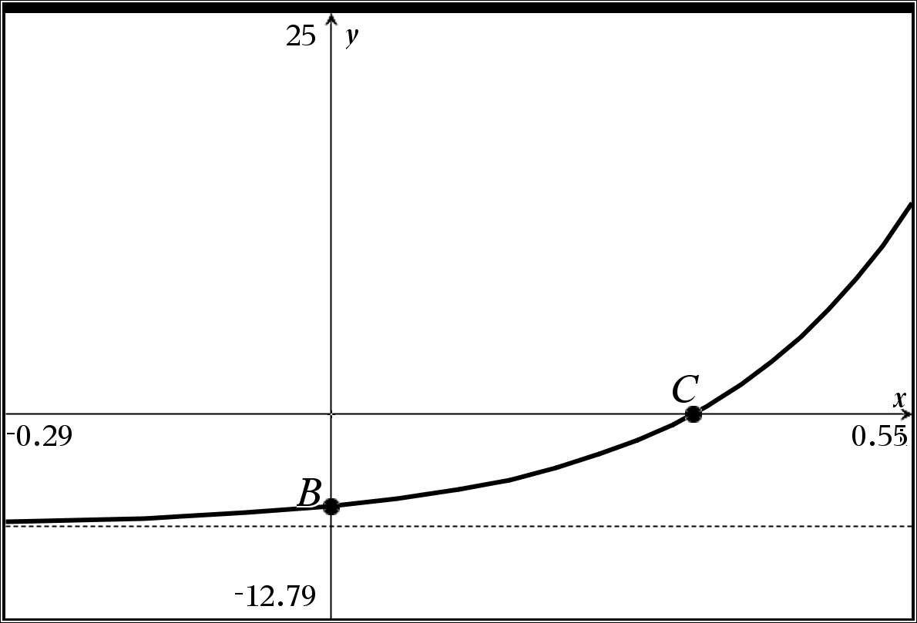
- Show the ALGEBRA necessary to find point C

- Complete the related table
Point A | Point B | Point C | Point D | Horizontal Asymptote
 | Exact  Approximate | Exact  Approximate | Exact  Approximate
Give an exact and approximate answer when necessary (You will need the use of a logarithm for this problem)
- $-3∙4^{-5x+1}-2=-8$

Graph of the related system  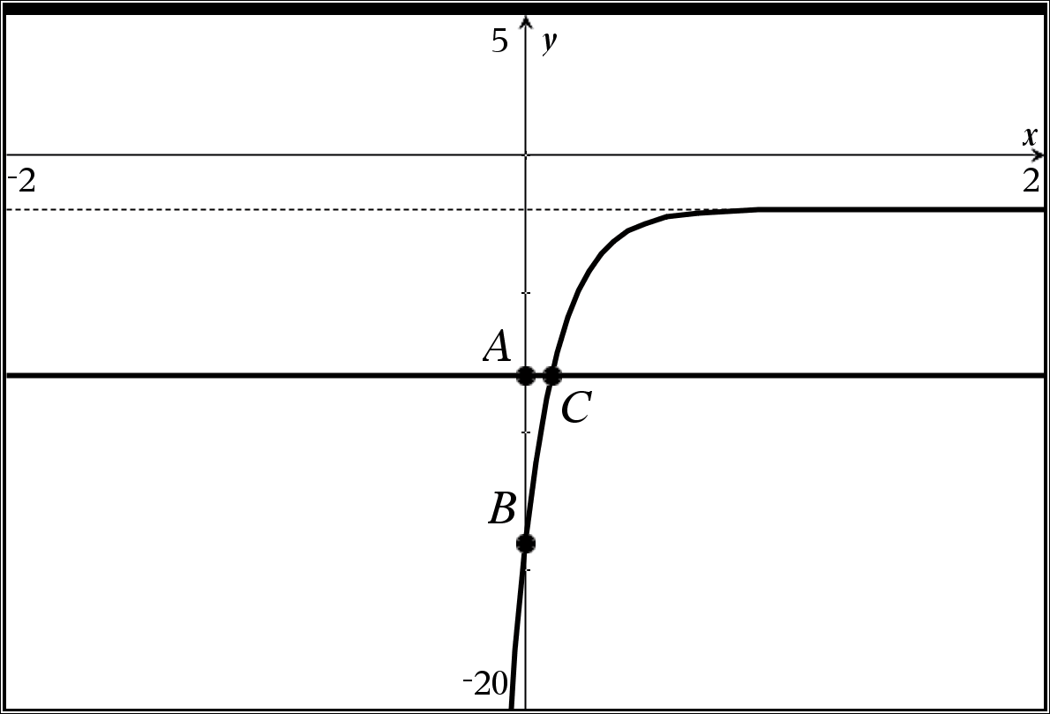 | Graph of the related system  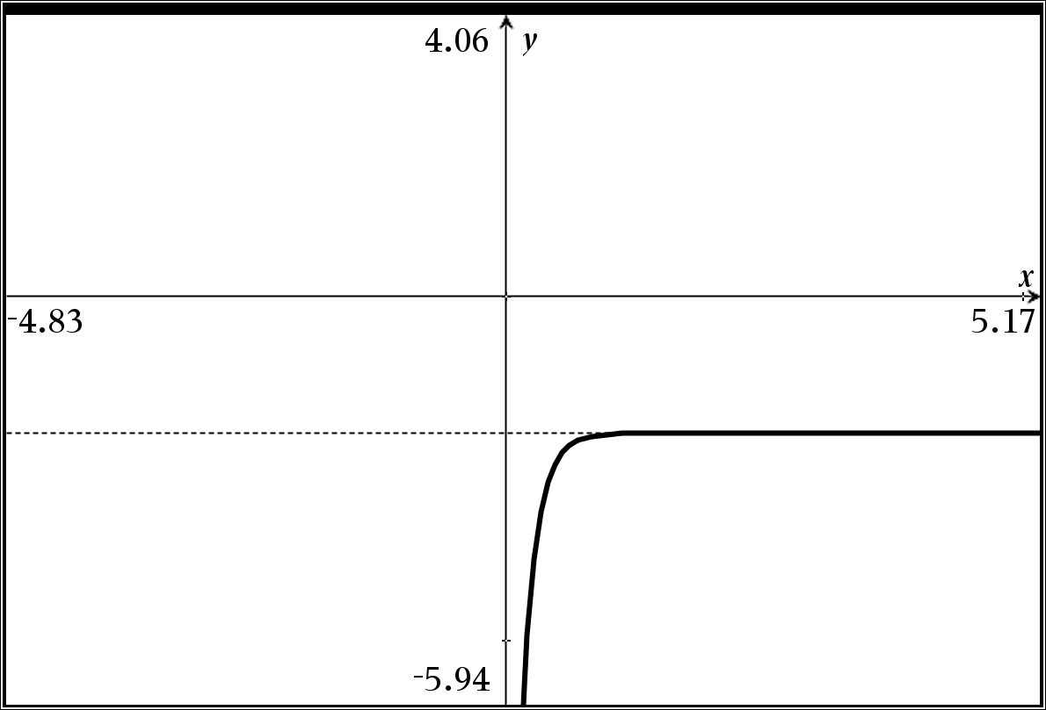

- Complete the related table
Point A | Point B | Point C | Horizontal Asymptote
 | Exact  Approximate | Exact  Approximate

Extra Credit 1: Give an example of how you intend to keep your mind active over the summer

Give an exact and approximate answer when necessary (You will need the use of a logarithm for this problem)
- $5∙{10}^{-x+1}=75$

Graph of the related system
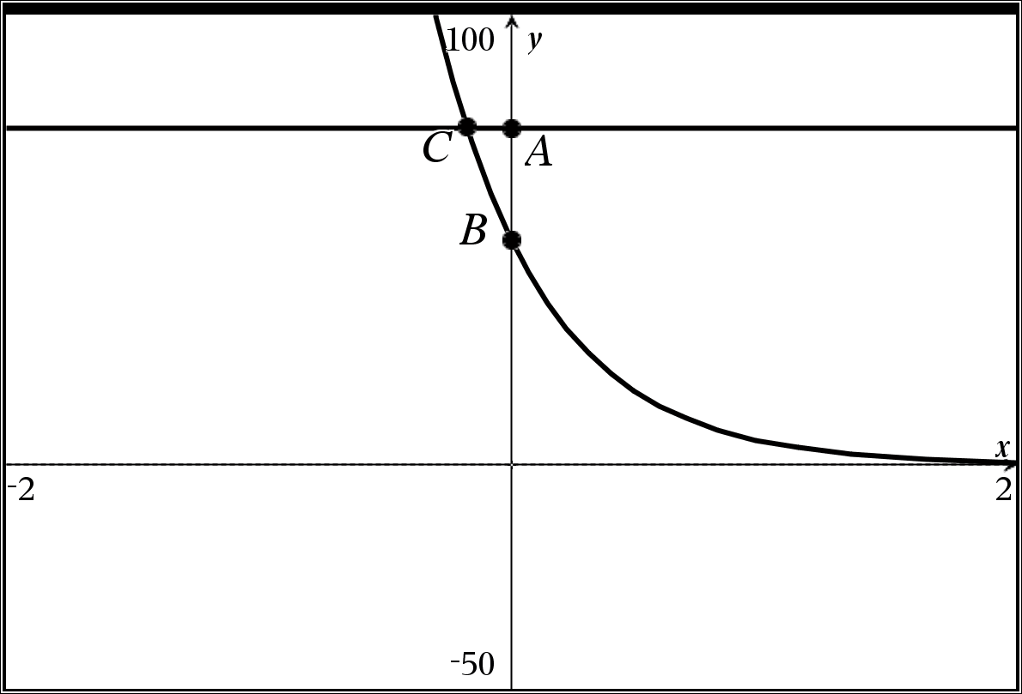
- Complete the related table
Point A | Point B | Point C | Horizontal Asymptote
 | Exact  Approximate | Exact  Approximate

Extra Credit #2: Which better describes your next step in mathematics and why? Exciting Scary

Give an exact and approximate answer when necessary (You will need the use of a logarithm for this problem)
- $\frac{-1}{3}∙e^{3x-6}-3=-6$

Graph of the related system
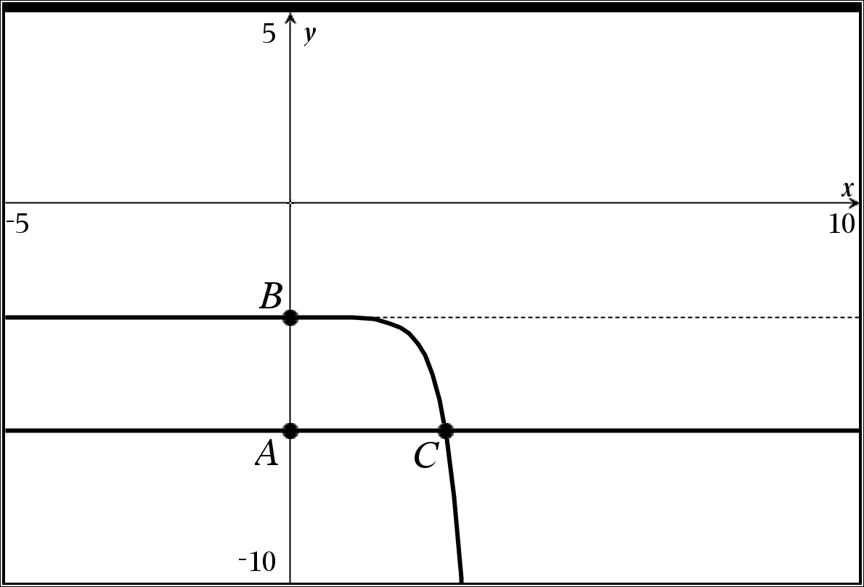
- Complete the related table
Point A | Point B | Point C | Horizontal Asymptote
 | Exact  Approximate | Exact  Approximate

Extra Credit #3 If you could thank only one teacher for what they have done for you this year, what would it be for?

