Name______________________________Formative Assessment Rational Function Parts, Graphs, & Behavior Period_________
- $f\left(x\right)=\frac{{-x}^{2}-4x-4}{x^{2}-4}=\frac{-1(x+2)(x+2)}{(x-2)(x+2)}$
Completely simplified function  (if simplification is possible) | X intercept(s)  State as a point | Y intercept  State as a point | Vertical Asymptote(s)  State as a line | Horizontal Asymptote  State as a line | Hole(s)  State as a point

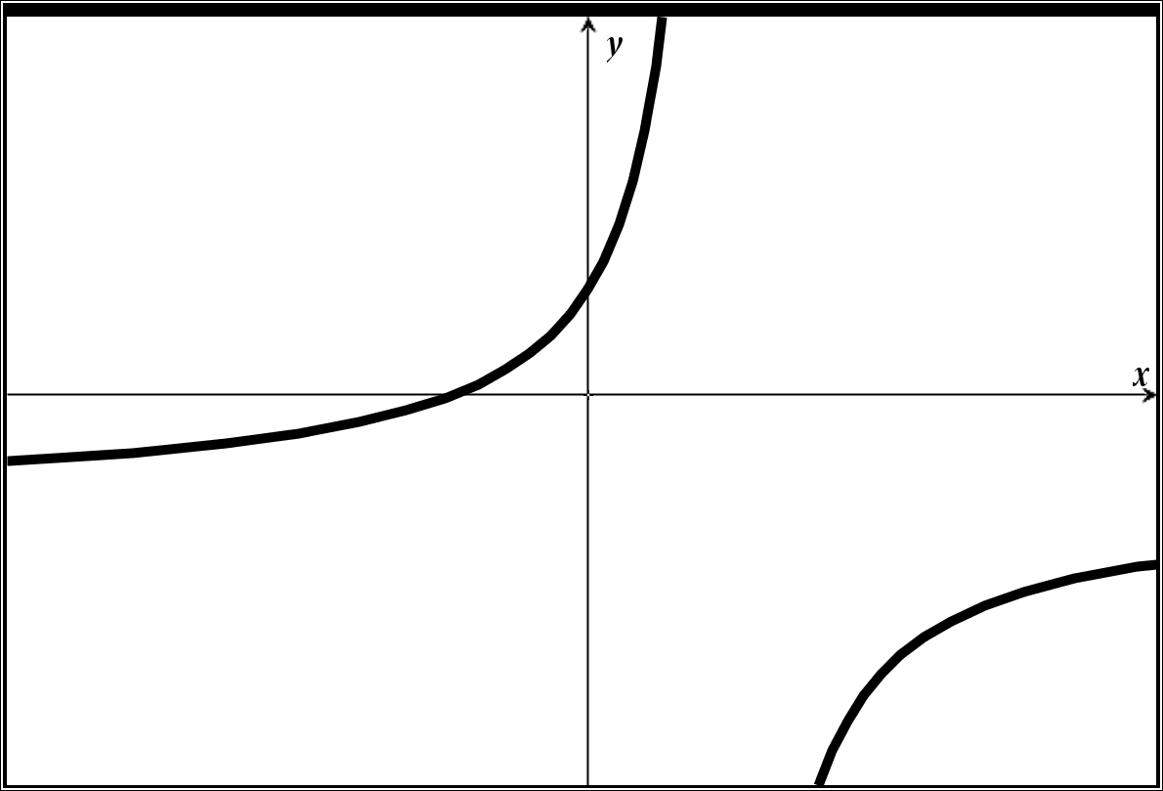
- Label the given graph with the points, holes, and asymptotes from the table above
Hole and Points need coordinates
Asymptotes need equations of lines

Show any necessary work here

- State the domain of the rational function using two different methods  Method 1  Method 2 | - Complete the behavior statements with the appropriate value of y or +∞ or -∞  As x → -2⁻ y →_______  (this asks as x approaches -2 from the left, what y value does the function approach?)  As x → 2⁺ y →_______  (this asks as x approaches 2 from the right, what y value does the function approach?)  As x → -∞ y →_______  (this asks “what is the left end behavior of the function?)  As x → ∞ y →_______  (this asks “what is the right end behavior of the function?)

- $g\left(x\right)=\frac{x^{2}-4x}{x^{2}-4}=\frac{x(x-4)}{(x-2)(x+2)}$
Completely simplified function  (if simplification is possible) | X intercept(s)  State as a point | Y intercept  State as a point | Vertical Asymptote(s)  State as a line | Horizontal Asymptote  State as a line | Hole(s)  State as a point

- Label the given graph with the points, holes, and asymptotes from the table above
Hole and Points need coordinates
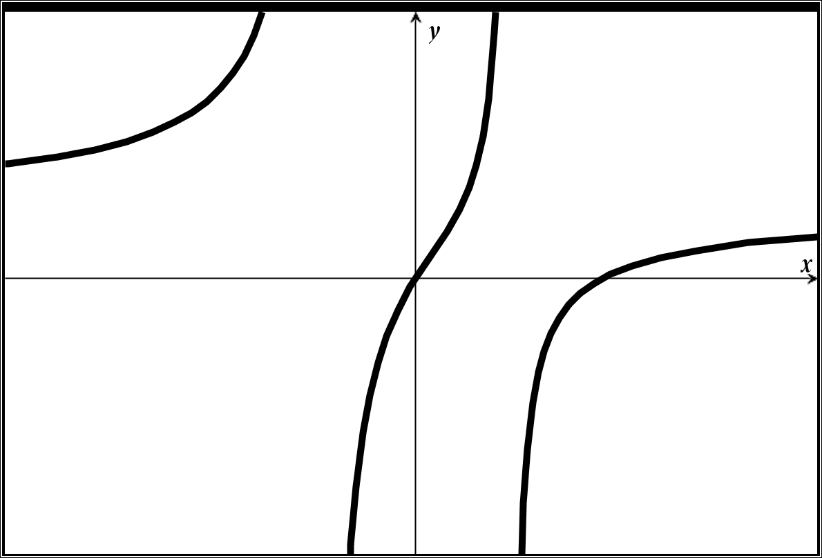
Asymptotes need equations of lines

Show any necessary work here

- State the domain of the rational function using two different methods  Method 1  Method 2 | - Complete the behavior statements with the appropriate value of y or +∞ or -∞  As x → -2⁻ y →_______  (this asks as x approaches -2 from the left, what y value does the function approach?)  As x → 4⁺ y →_______  (this asks as x approaches 4 from the right, what y value does the function approach?)  As x → -∞ y →_______  (this asks “what is the left end behavior of the function?)  As x → ∞ y →_______  (this asks “what is the right end behavior of the function?)

- $h\left(x\right)=\frac{x^{3}-4x^{2}-12x}{x^{2}-x}=\frac{x(x-6)(x+2)}{x(x-1)}$
Completely simplified function  (if simplification is possible) | X intercept(s)  State as a point | Y intercept  State as a point | Vertical Asymptote(s)  State as a line | Horizontal Asymptote  State as a line | Hole(s)  State as a point

- Label the given graph with the points, holes, and asymptotes from the table above
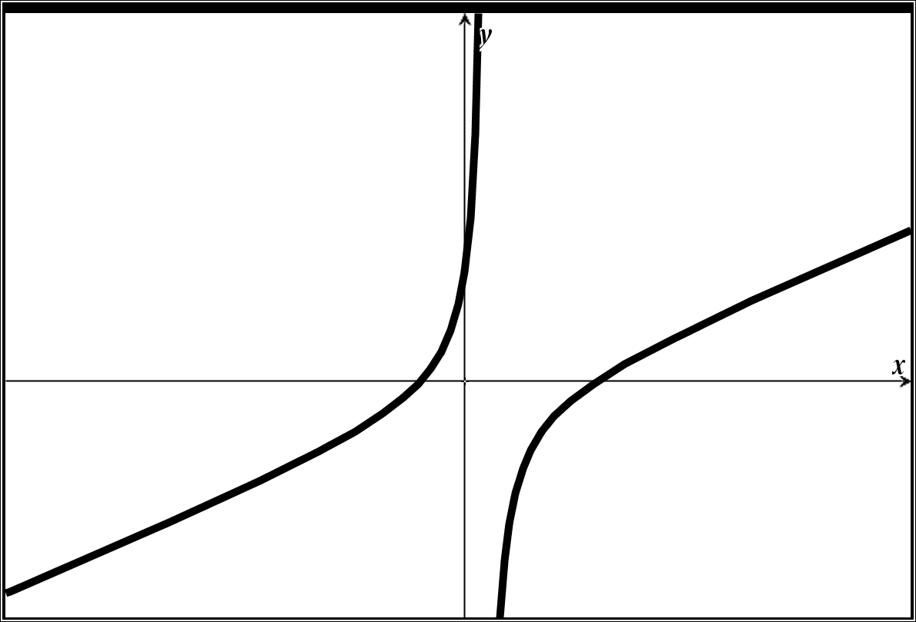
Hole and Points need coordinates
Asymptotes need equations of lines

Show any necessary work here

- State the domain of the rational function using two different methods  Method 1  Method 2 | - Complete the behavior statements with the appropriate value of y or +∞ or -∞  As x → 1⁻ y →_______  (this asks as x approaches 1 from the left, what y value does the function approach?)  As x → 0⁺ y →_______  (this asks as x approaches 0 from the right, what y value does the function approach?)  As x → -∞ y →_______  (this asks “what is the left end behavior of the function?)  As x → ∞ y →_______  (this asks “what is the right end behavior of the function?)

- $j\left(x\right)=\frac{x^{2}-4x}{{4x}^{3}+8x}=\frac{x(x-4)}{4x(x^{2}+8)}$
Completely simplified function  (if simplification is possible) | X intercept(s)  State as a point | Y intercept  State as a point | Vertical Asymptote(s)  State as a line | Horizontal Asymptote  State as a line | Hole(s)  State as a point

- Label the given graph with the points, holes, and asymptotes from the table above
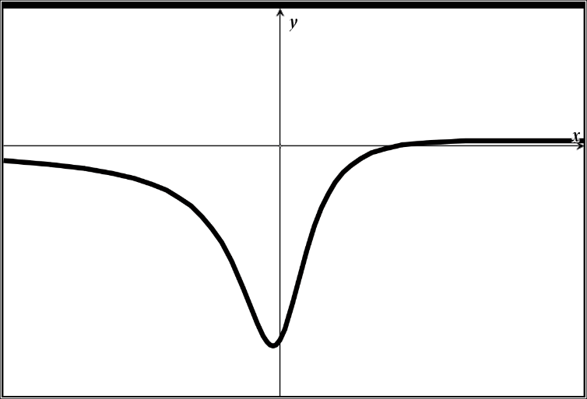
Hole and Points need coordinates
Asymptotes need equations of lines

Show any necessary work here

- State the domain of the rational function using two different methods  Method 1  Method 2 | - Complete the behavior statements with the appropriate value of y or +∞ or -∞  As x → 5⁻ y →_______  (this asks as x approaches 1 from the left, what y value does the function approach?)  As x → 0⁺ y →_______  (this asks as x approaches 0 from the right, what y value does the function approach?)  As x → -∞ y →_______  (this asks “what is the left end behavior of the function?)  As x → ∞ y →_______  (this asks “what is the right end behavior of the function?)

