Name______________________________________________ Linear Speed and Angular Speed 10-18-17
Warmup Questions
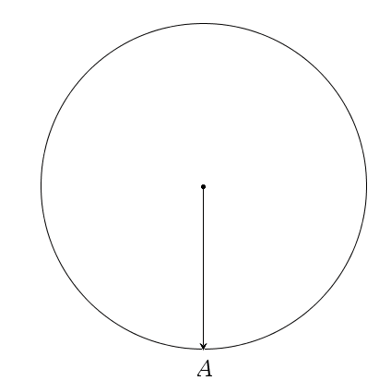 | If have a wheel with radius r, then how far does point A travel in one revolution along the ground?  If you travel with this same wheel, 12.5 revolutions then how far does point A travel in 12.5 revolutions along the ground?  Sketch the location of A after 12.5 revolutions  If your wheel took t time to complete 12.5 revolutions, then what is the angular speed?  If your wheel took t time to complete 12.5 revolutions, then what is the linear speed?

If have a wheel with radius 10 meters, then how far does point A travel in one revolution along the ground?

If you travel with this same wheel, 12.5 revolutions then how far does point A travel in 12.5 revolutions along the ground?

Sketch the location of A after 12.5 revolutions

If your wheel took 500 seconds to complete 12.5 revolutions, then what is the angular speed?

If your wheel took 500 seconds to complete 12.5 revolutions, then what is the linear speed?

