Name________________________________________ ES Latitude Problems 10-18-17 hour 1 2 3 4 5 6 7
Assume that the planet has a radius of 4000 m. Assume the both towns lie on the same longitude.
Directions: 1) Sketch and label a REALISTIC figure on the provided circle
2) SHOW YOUR WORK IN A CLEAR MANNER
3) USE AT LEAST THREE DECIMAL PLACE APPROXIMATIONS IN YOUR CALCULATIONS
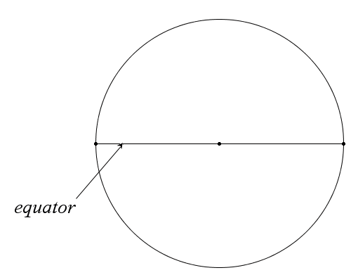 | Town A has a latitude of 68°56’25”N  Town B has a latitude of 22°12’52”N  Find out how far apart these towns are from each other
Town C has a latitude of 52°14’05”N
Town D has a latitude of 48°21’36”S

Find out how far apart these towns are from each other

Town E has a latitude of 16°57’18”N
Town F has UNKNOWN latitude

These towns are 250 miles apart, determine the latitude of Town F
Express the UNKNOWN latitude of TOWN F in DMS and DD

I realize that DMS is an annoying notation, so I am going to tell you the “trick” button most calculators have.
D°M’S”

You will be required to show the conversion by hand once on an assessment, then you will be allowed to use this button afterward with no penalty for avoiding the tedious work of the notation
ON THE TINSPIRE the button to the right of the number 9 is the COOL stuff Menu button,
this D°M’S” button lives on this menu

I have located the button on my calculator YES NO
My calculator does NOT have a cool button like this (check with Mr. Hickman on this) YES NO

Name________________________________________ ES Latitude Problems 10-18-17 hour 1 2 3 4 5 6 7
Assume that the planet has a radius of 4000 m. Assume the both towns lie on the same longitude.
Directions: 1) Sketch and label a REALISTIC figure on the provided circle
2) SHOW YOUR WORK IN A CLEAR MANNER
3) USE AT LEAST THREE DECIMAL PLACE APPROXIMATIONS IN YOUR CALCULATIONS
Town A has a latitude of 59°32’35”N
Town B has a latitude of 42°22’42”N

Find out how far apart these towns are from each other

Town C has a latitude of 71°18’56”N
Town D has a latitude of 5°41’26”S

Find out how far apart these towns are from each other

Town E has a latitude of 24°52’38”N
Town F has UNKNOWN latitude

These towns are 350 miles apart, determine the latitude of Town F

I realize that DMS is an annoying notation, so I am going to tell you the “trick” button most calculators have.
D°M’S”

You will be required to show the conversion by hand once on an assessment, then you will be allowed to use this button afterward with no penalty for avoiding the tedious work of the notation
ON THE TINSPIRE the button to the right of the number 9 is the COOL stuff Menu button,
this D°M’S” button lives on this menu

I have located the button on my calculator YES NO
My calculator does NOT have a cool button like this (check with Mr. Hickman on this) YES NO

Name________________________________________ ES Latitude Problems 10-18-17 hour 1 2 3 4 5 6 7
Assume that the planet has a radius of 4000 m. Assume the both towns lie on the same longitude.
Directions: 1) Sketch and label a REALISTIC figure on the provided circle
2) SHOW YOUR WORK IN A CLEAR MANNER
3) USE AT LEAST THREE DECIMAL PLACE APPROXIMATIONS IN YOUR CALCULATIONS
Town A has a latitude of 65°51’15”N
Town B has a latitude of 42°32’42”N

Find out how far apart these towns are from each other

Town C has a latitude of 62°19’25”N
Town D has a latitude of 38°51’46”S

Find out how far apart these towns are from each other

Town E has a latitude of 26°47’58”N
Town F has UNKNOWN latitude

These towns are 450 miles apart, determine the latitude of Town F
Express the UNKNOWN latitude of TOWN F in DMS and DD

I realize that DMS is an annoying notation, so I am going to tell you the “trick” button most calculators have.
D°M’S”

You will be required to show the conversion by hand once on an assessment, then you will be allowed to use this button afterward with no penalty for avoiding the tedious work of the notation
ON THE TINSPIRE the button to the right of the number 9 is the COOL stuff Menu button,
this D°M’S” button lives on this menu

I have located the button on my calculator YES NO
My calculator does NOT have a cool button like this (check with Mr. Hickman on this) YES NO

