Name________________________________  SA Transformations of Sine and Cosine  Writing a Function from its Graph  Graphing a Function from its Function | 2nd hour 3rd hour 4th hour  5th hour 6th hour 7th hour

Write the equation of the given trigonometric function, answer the related questions, and select the related transformations

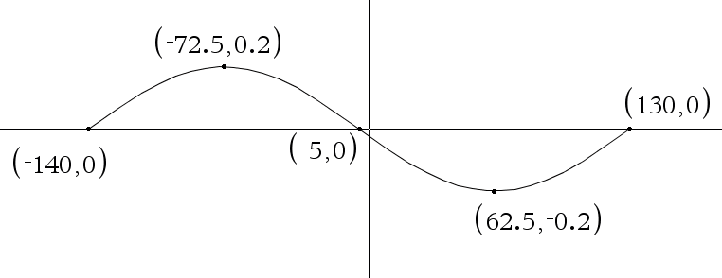 | - Write the trigonometric function in the given graph in both formats  General Trigonometric Function  ________________________________________________  Translated Trigonometric Function  __________________________________________________

- Complete the related table
A | B | C | D | Amplitude | Phase shift | Period Length | State implied period

- Circle the related transformations
Vertical  Compression | Vertical  Stretch | Vertical  Reflection | Horizontal  Compression | Horizontal  Stretch | Phase Shift LEFT | Phase Shift RIGHT

Show any related work here

Extra Credit #1:
Which is more special to you and why?
A nice gesture when EXPECTED like your birthday, Valentine’s Day, or an anniversary, or a nice gesture when UNEXPECTED.

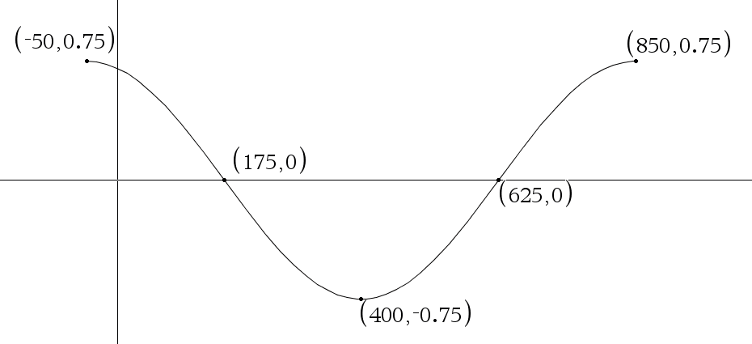 | - Write the trigonometric function in the given graph in both formats  General Trigonometric Function  ________________________________________________  Translated Trigonometric Function  __________________________________________________
- Complete the related table
A | B | C | D | Amplitude | Phase shift | Period Length | State implied period

- Circle the related transformations
Vertical  Compression | Vertical  Stretch | Vertical  Reflection | Horizontal  Compression | Horizontal  Stretch | Phase Shift LEFT | Phase Shift RIGHT

Show any related work here

Extra Credit #2: Give an example of when you learned a lesson about the nature of friendships you have had in the past. Was this lesson a positive or negative experience?

$f\left(x\right)=\frac{-5}{7}\cos\left(\frac{8}{5}x-80\right)$

state the translated version of this trigonometric function______________________________________

A | B | C | D

State any extreme value points or intercepts in the IMPLIED period as POINTS when angles are measured in degrees

Label as Point K on graph below  ( , ) | Label as Point N on graph below  ( , ) | Label as point I on graph below  ( , ) |  | Label as point G on graph below  ( , ) | Label as point H on graph below  ( , )
State each of these (these depend on A and D)  Range of the function Midline of the function Amplitude of the function  State each of these (these depend on B and C)  Length of ONE PERIOD of the function Period that is IMPLIED by this function PHASE Shift of this function (be certain to state direction and number) |  |  | Sketch g(x) label the FIVE important points  (use the letters from above)

Circle the related transformations

Vertical  Compression | Vertical  Stretch | Vertical  Reflection | Horizontal  Compression | Horizontal  Stretch | Phase Shift LEFT | Phase Shift RIGHT

$g\left(x\right)=\frac{-5}{6}\sin\left(\frac{4}{3}x-96\right)$

state the translated version of this trigonometric function______________________________________

A | B | C | D

State any extreme value points or intercepts in the IMPLIED period as POINTS when angles are measured in degrees

Label as Point K on graph below  ( , ) | Label as Point N on graph below  ( , ) | Label as point I on graph below  ( , ) |  | Label as point G on graph below  ( , ) | Label as point H on graph below  ( , )
State each of these (these depend on A and D)  Range of the function Midline of the function Amplitude of the function  State each of these (these depend on B and C)  Length of ONE PERIOD of the function Period that is IMPLIED by this function PHASE Shift of this function (be certain to state direction and number) |  |  | Sketch g(x) label the FIVE important points  (use the letters from above)

Name________________________________  SA Transformations of Sine and Cosine  Writing a Function from its Graph  Graphing a Function from its Function | 2nd hour 3rd hour 4th hour  5th hour 6th hour 7th hour

Write the equation of the given trigonometric function, answer the related questions, and select the related transformations

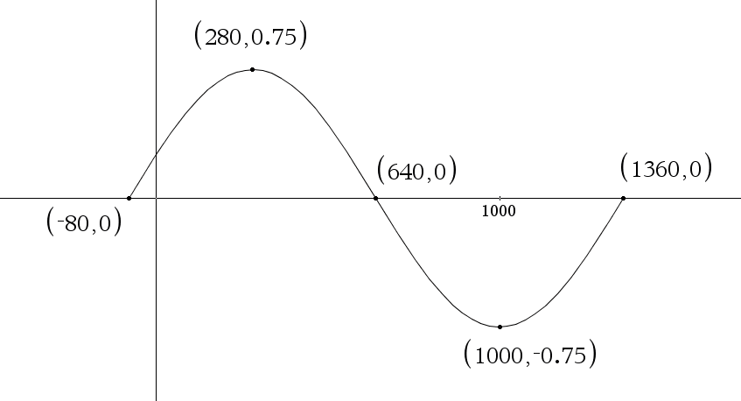 | - Write the trigonometric function in the given graph in both formats  General Trigonometric Function  ________________________________________________  Translated Trigonometric Function  __________________________________________________

- Complete the related table
A | B | C | D | Amplitude | Phase shift | Period Length | State implied period

- Circle the related transformations
Vertical  Compression | Vertical  Stretch | Vertical  Reflection | Horizontal  Compression | Horizontal  Stretch | Phase Shift LEFT | Phase Shift RIGHT

Show any related work here

Extra Credit #1:
Which is more special to you and why?
A nice gesture when EXPECTED like your birthday, Valentine’s Day, or an anniversary, or a nice gesture when UNEXPECTED.

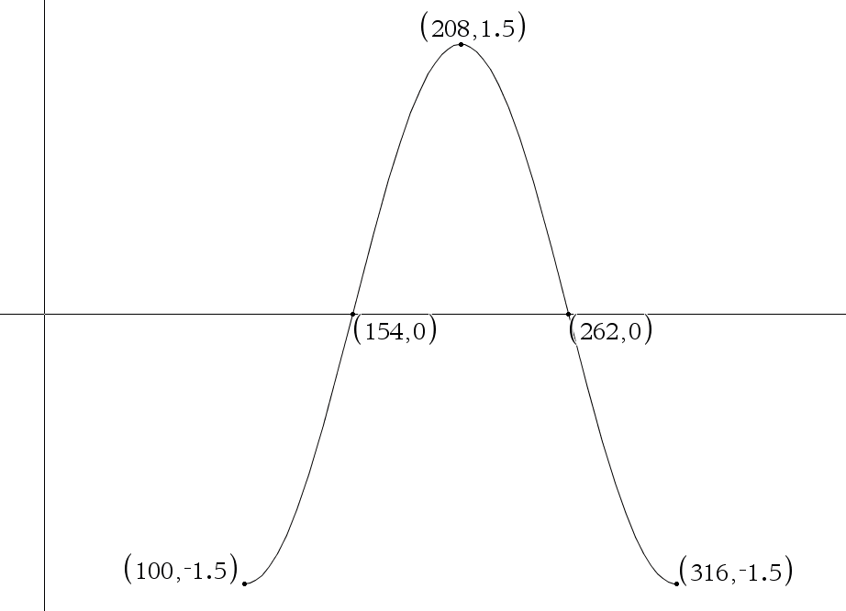 | - Write the trigonometric function in the given graph in both formats  General Trigonometric Function  ________________________________________________  Translated Trigonometric Function  __________________________________________________
- Complete the related table
A | B | C | D | Amplitude | Phase shift | Period Length | State implied period

- Circle the related transformations
Vertical  Compression | Vertical  Stretch | Vertical  Reflection | Horizontal  Compression | Horizontal  Stretch | Phase Shift LEFT | Phase Shift RIGHT

Show any related work here

Extra Credit #2: Give an example of when you learned a lesson about the nature of friendships you have had in the past. Was this lesson a positive or negative experience?

$f\left(x\right)=-\frac{5}{3}\sin\left(\frac{8}{3}x-72\right)$

state the translated version of this trigonometric function______________________________________

A | B | C | D

State any extreme value points or intercepts in the IMPLIED period as POINTS when angles are measured in degrees

Label as Point K on graph below  ( , ) | Label as Point N on graph below  ( , ) | Label as point I on graph below  ( , ) |  | Label as point G on graph below  ( , ) | Label as point H on graph below  ( , )
State each of these (these depend on A and D)  Range of the function Midline of the function Amplitude of the function  State each of these (these depend on B and C)  Length of ONE PERIOD of the function Period that is IMPLIED by this function PHASE Shift of this function (be certain to state direction and number) |  |  | Sketch g(x) label the FIVE important points  (use the letters from above)

Circle the related transformations

Vertical  Compression | Vertical  Stretch | Vertical  Reflection | Horizontal  Compression | Horizontal  Stretch | Phase Shift LEFT | Phase Shift RIGHT

$g\left(x\right)=\frac{2}{5}\cos\left(\frac{5}{3}x+90\right)$

state the translated version of this trigonometric function______________________________________

A | B | C | D

State any extreme value points or intercepts in the IMPLIED period as POINTS when angles are measured in degrees

Label as Point K on graph below  ( , ) | Label as Point N on graph below  ( , ) | Label as point I on graph below  ( , ) |  | Label as point G on graph below  ( , ) | Label as point H on graph below  ( , )
State each of these (these depend on A and D)  Range of the function Midline of the function Amplitude of the function  State each of these (these depend on B and C)  Length of ONE PERIOD of the function Period that is IMPLIED by this function PHASE Shift of this function (be certain to state direction and number) |  |  | Sketch g(x) label the FIVE important points  (use the letters from above)

Name________________________________  SA Transformations of Sine and Cosine  Writing a Function from its Graph  Graphing a Function from its Function | 2nd hour 3rd hour 4th hour  5th hour 6th hour 7th hour

Write the equation of the given trigonometric function, answer the related questions, and select the related transformations

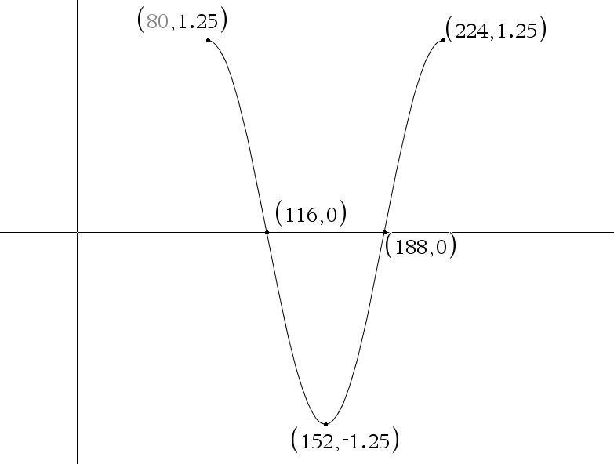 | - Write the trigonometric function in the given graph in both formats  General Trigonometric Function  ________________________________________________  Translated Trigonometric Function  __________________________________________________

- Complete the related table
A | B | C | D | Amplitude | Phase shift | Period Length | State implied period

- Circle the related transformations
Vertical  Compression | Vertical  Stretch | Vertical  Reflection | Horizontal  Compression | Horizontal  Stretch | Phase Shift LEFT | Phase Shift RIGHT

Show any related work here

Extra Credit #1:
Which is more special to you and why?
A nice gesture when EXPECTED like your birthday, Valentine’s Day, or an anniversary, or a nice gesture when UNEXPECTED.

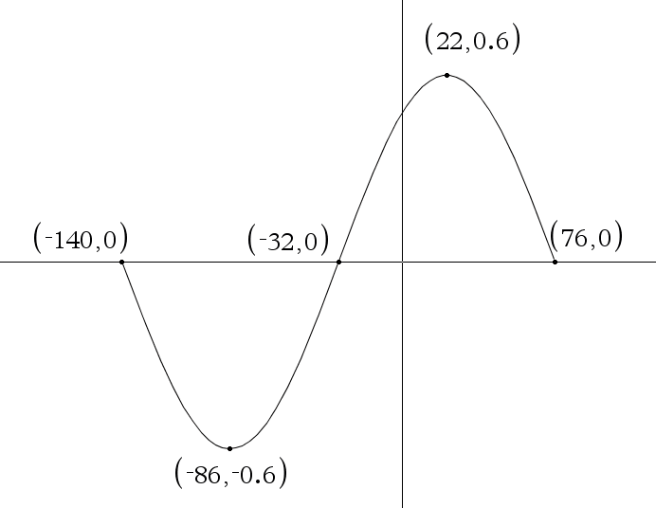 | - Write the trigonometric function in the given graph in both formats  General Trigonometric Function  ________________________________________________  Translated Trigonometric Function  __________________________________________________
- Complete the related table
A | B | C | D | Amplitude | Phase shift | Period Length | State implied period

- Circle the related transformations
Vertical  Compression | Vertical  Stretch | Vertical  Reflection | Horizontal  Compression | Horizontal  Stretch | Phase Shift LEFT | Phase Shift RIGHT

Show any related work here

Extra Credit #2: Give an example of when you learned a lesson about the nature of friendships you have had in the past. Was this lesson a positive or negative experience?

$f\left(x\right)=\frac{7}{8}\sin\left(\frac{9}{5}x-80\right)$

state the translated version of this trigonometric function______________________________________

A | B | C | D

State any extreme value points or intercepts in the IMPLIED period as POINTS when angles are measured in degrees

Label as Point K on graph below  ( , ) | Label as Point N on graph below  ( , ) | Label as point I on graph below  ( , ) |  | Label as point G on graph below  ( , ) | Label as point H on graph below  ( , )
State each of these (these depend on A and D)  Range of the function Midline of the function Amplitude of the function  State each of these (these depend on B and C)  Length of ONE PERIOD of the function Period that is IMPLIED by this function PHASE Shift of this function (be certain to state direction and number) |  |  | Sketch g(x) label the FIVE important points  (use the letters from above)

Circle the related transformations

Vertical  Compression | Vertical  Stretch | Vertical  Reflection | Horizontal  Compression | Horizontal  Stretch | Phase Shift LEFT | Phase Shift RIGHT

$g\left(x\right)=\frac{5}{6}\cos\left(\frac{1}{4}x+96\right)$

state the translated version of this trigonometric function______________________________________

A | B | C | D

State any extreme value points or intercepts in the IMPLIED period as POINTS when angles are measured in degrees

Label as Point K on graph below  ( , ) | Label as Point N on graph below  ( , ) | Label as point I on graph below  ( , ) |  | Label as point G on graph below  ( , ) | Label as point H on graph below  ( , )
State each of these (these depend on A and D)  Range of the function Midline of the function Amplitude of the function  State each of these (these depend on B and C)  Length of ONE PERIOD of the function Period that is IMPLIED by this function PHASE Shift of this function (be certain to state direction and number) |  |  | Sketch g(x) label the FIVE important points  (use the letters from above)

